**CHLOROPLAST**  1. The chloroplast was described by Nehemiah and Antony Von Leuwenhock. 2. Later Mayer described the structure of chloroplast in detail. 3. The chloroplast are the common plastids of plant cell. 4. It performs the photosynthetic activity. 5. By the process of photosynthesis, it synthesis the carbohydrate. 6. The carbohydrates contains the energy in the form of chemical energy. 7. This chemical energy is utilized by all living beings for various functions.

**DISTRIBUTION/OCCURRENCE** The chloroplast are present in the cytoplasm of the plant cell.

**MARPHOLOGY** **I. Shape** :- 1. It is generally biconvex in shape. 2. In some it is filamentous, saucer shape, spheroid, ovoid, discoid or club shaped. **II. Size :-** 1. The size of chloroplast varies from species to species. 2. It is generally 2 – 3 thick & 5 – 10 in diameter. 3. In polyploidy plant cells the chloroplast are of larger size in the comparison of diploid plant cells. 4. The shady plants have large chloroplast than the sunlight plants.

**NUMBER** 1. The number varies from cell to cell and species to species. 2. The number of chloroplast is related with the physiological activity of the cell. 3. The algal cell have single chloroplast. 4. The higher plant cell have 20 – 40 to 1000 chloroplast.

**CHEMICAL COMPOSITION** 1. The chloroplast is composed of carbohydrate, lipid, protein, chlorophyll, carotenoids, DNA, RNA & of enzymes. It also have some ions of Fe, Cu, Mn and Zn. 2. The percentage of carbohydrate are low in chloroplast.The common carbohydrate in chloroplast are starch and sugar phosphate. 3. The lipid are in 20 – 30%. 4. The protein are 35 – 55%. Among this the 80% protein are insoluble and the 20% protein are soluble in enzyme form. The protein forms the membrane of chloroplast. 5. The chlorophyll is a green pigment of chloroplast. The chlorophyll have 75% Chl.a and 25% of Chl.b.

**STRUCTURE** 1. The chloroplast is bounded by two membrane :- (i). Outer membrane & (ii). Inner membrane. 2. Both the membrane are lipo-proteinaceous in nature and 50A* in thickness. 3. Both the membrane are separated by a space called periplastidial space. 4.It shows following structure :- I. Matrix/Stroma II. Grana

**I. Matrix** :- i. It is found inside the inner membrane. ii. It is a watery and transparent substance. iii. The grana and intergrana are embedded in it. iv. It is a site of dark reaction of photosynthesis.

**II. Grana** :- i.The chloroplast have many granular and chlorophyll bearing structure called grana. ii. It is a site of light reaction of photosynthesis. iii. It is found in the matrix. iv. The number of grana in chloroplast is 40 – 60. v. Each grana are composed of 10 – 100 disc like superimposed (laying one after another), oval shaped thylakoids. The thylakoids are arranged parallel in stack form. vi. Each thylakoid has own membrane. vii. Each grana are connected by membranous tubules arising from thylakoids called lamellae or frets.

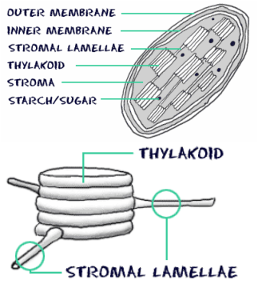

**FUNCTION**  The chlorophyll of chloroplast trap the solar energy and transform it into chemical energy.

JANARDAN PRASAD SINGH DEPARTMENT OF BOTANY VISTHAPIT MAHAVIDYALAYA, BALIDIH