**GRAM** English name :- Chick Pea  Vernacular name :- Chana Botanical name :- Cicer arietinum **CLASSIFICATION** Class :- Equisetopsida Order :- Fabales Family :- Leguminoaceae/Fabaceae Genus :- Cicer species :- arietinum

1. It is an  [annual](https://en.wikipedia.org/wiki/Annual_plant)  [legume](https://en.wikipedia.org/wiki/Legume). 2. It is believed to have originated from Turkey. 3.  Its different types and variably are known as  Bengal gram, Garbanzo (Kabuli chana) or  Egyptian pea. 4. It is one of the earliest cultivated legumes. 5. It is a cool-season legumes.

**DISTRIBUTION/OCCURRENCE**  1. It is believed to have originated from Turkey. 2. It is grown mostly in  [India](https://en.wikipedia.org/wiki/India)  and other parts of the  [Indian subcontinent](https://en.wikipedia.org/wiki/Indian_subcontinent), as well as other gram growing countries in the world are Iran, Iraq, Algeria, Greece, Italy, Portugal, Spain, [Ethiopia](https://en.wikipedia.org/wiki/Ethiopia), [Mexico](https://en.wikipedia.org/wiki/Mexico) and  [Iran](https://en.wikipedia.org/wiki/Iran). 3. In India, it is chiefly grown in states Punjab, Uttar Pradesh, Bihar, Madhya Pradesh, Andhra Pradesh etc. 4. India yields 90% of the total world production of Gram. 5. It occupies 38% of area and contributes about 50% of the total pulse production in India. 6. It is a cool-season legumes which are best grown as a winter crop in the tropics or as a spring or summer crop in temperate regions.

**NUTRITION** 1. Gram provides rich content of  [protein](https://en.wikipedia.org/wiki/Protein), [dietary fiber](https://en.wikipedia.org/wiki/Dietary_fiber), and certain  [minerals](https://en.wikipedia.org/wiki/Dietary_minerals), Such as  [iron](https://en.wikipedia.org/wiki/Iron),  [phosphorus](https://en.wikipedia.org/wiki/Phosphorus) etc.  2. It also has  [Thiamin](https://en.wikipedia.org/wiki/Thiamin), [vitamin B6](https://en.wikipedia.org/wiki/Vitamin_B6), [magnesium](https://en.wikipedia.org/wiki/Magnesium), and  [zinc](https://en.wikipedia.org/wiki/Zinc)  contents. 3. Germinated gram are rich in Thiamin, vitamin, aminoacids. Such as lysine, isoleucine, tryptophan etc. 4. Cooked gram have [carbohydrates](https://en.wikipedia.org/wiki/Carbohydrates), [protein](https://en.wikipedia.org/wiki/Protein) , [fat](https://en.wikipedia.org/wiki/Fat) and folic acid.

**BOTANICAL DESCRIPTION/STRUCTURE** 1. It is a small, herbaceous, [annual](https://en.wikipedia.org/wiki/Annual_plant)  plant. 2. It is a bushy plant.

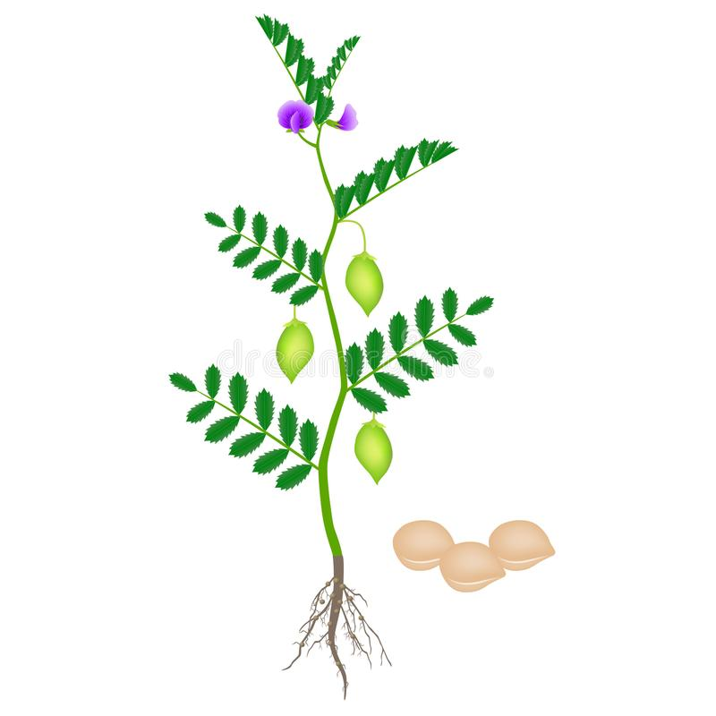

**Root** :- 1. It has a tap root system. 2. The central root is with numerous lateral branches which spread out in all directions. **Stem** :- 1. The plant grows to 20 – 50 cm. (2 feet or more) high. 2. The stem is branched, straight or bending, bushy spreading type. 3. The stem is generally greenish in colour. 4. The variety Kabuli chana is generally taller than the local Indian crop. **Leaves** :- 1. The plants bear feathery pinnately  [compound](https://www.merriam-webster.com/dictionary/compound)  [leaves](https://www.britannica.com/science/leaf-plant-anatomy) usually with one terminal leaflet. 2. The leaves are small, arranged alternately on either side of the stem. 3. The number of leaflets (11–15) however vary in plants. 4. The leaflets are of small size with serrated edges and oval in shape. 5. The colour of leaves also varies, some are light green while other are dark green. **Inflorescence/Flower** :- 1. The flowers are usually singly or in pairs in the axil of leaves. 2. It has white flowers with blue, violet, or pink veins. **Fruit (pod)** :- 1. Its one pod containing 2 – 3 seeds. 2. The pod is ellipsoid shaped. 3. A single plant produces about 50 – 150 pods. **Seed** :- 1. The seeds are small and have a rough coat. 2. The seeds are spherical, wrinkled with a pointed beak. 3. They vary in size as well as in colour. 4. The seeds are brown, Orange, yellowish, green or black. 5. Kabuli chana seeds are light-coloured, large and with a smooth coat.

**CULTIVATION/PLANTING** 1. Planting  of Gram is done from seed. 2. It is a winter (spring) season crop, but severe cold are injurious to it. 3. It is sown after the harvest of Kharif crop. 4. Generally 1 – 2 ploughing are given for seedbed. 5. Sowing is usually done in the beginning of October in most part of Northern India. 6. The crops should be planted when the soil has warmed to atleast 5°C. 7. Seed is usually sown by broadcasting or by drilling in rows. 8. The seed should be planted 2 cm. deep. 9. When planting in rows, seed should be spaced 10 cm. apart and space between the rows should be 25 – 60 cm. 10. The crop does not require any care after sowing. 11. The crop is usually not irrigated and rarely manured. 12. Seedlings usually emerge between 7 – 15 days after sowing depending on temperature.  13. Plants should be irrigated during dry weather but should not be to overwater because this can cause the plants to drop their flowers and pods.

**HARVESTING**   1. Grams are ready to harvest approximately 100 days after planting. 2. It can be harvested and eaten when green. 3. For dried seeds, harvesting is done when leaves turn brown and the plants begin to dry. 4. Plants are cut and taken to the threshing floor. 5. The cut plants are dried and then threshed by allowing the bullocks to tread upon them. 6. The pods should be allowed to dry and split open before collecting seeds. 7. The chaff (bhusa) is separated by winnowing.

**ECOLOGICAL FACTOR Climate** :- 1. It is a cool-season legumes. 2. It is fairly sensitive to the conditions of the weather. 3. Heavy showers soon after sowing or at flowering and fruiting stages cause great harm. 4. Frost during this period will result in the failure of the flower to develop seeds or in killing of the seeds inside the pod. 5. It grows best as a winter crop in the tropics or as a spring or summer crop in temperate regions. 6. It will grow in suitable temperatures between 15 – 29°C. 7. The temperature above 35°C. and below 15°C. the flowers start to drop and production reduces. 8. It needs annual rainfall between 600 – 1000 mm.

**Soil** :- 1. Plants will perform best well-draining sandy loam soils which is not to heavy. 2. So the gram is grown in fairly light soils. 3. The pH of soil should be 5.0 – 7.0. 4. In Maharashtra and South India, it is cultivated on water retentive (recollected) clay loams and black cotton soil.

**SOME VARIETIES OF GRAM** 1. Several varieties of gram are cultivated throughout the world.  2. Some of the varieties are :- CO – 2 , BDN – 9 – 3, BR – 77, BR – 78, H – 355, H – 208, B – 124, B – 110, Pusa – 209, Pusa – 261 etc.

**USES** 1. It is primarily consumed as a dry pulse. 2. It is extensively consumed by both animals and humans. 3. Its flour is used to make  [falafel](https://en.wikipedia.org/wiki/Falafel) (deep fried balls). 4. It is also used in salads, soups, curry and other meal products like chhole. 5. The seeds eaten as a raw snack and the leaves are eaten as a  [leaf vegetable](https://en.wikipedia.org/wiki/Leaf_vegetable). 6. It serve as an energy and protein source. 7. Gram consumption may lower  [blood cholesterol](https://en.wikipedia.org/wiki/Blood_cholesterol). 8. The seed husks can be used as a feed for animals.

JANARDAN PRASAD SINGH VISTHAPIT MAHAVIDYALAYA, BALIDIH DEPARTMENT OF BOTANY