**SAFFRON**  English name :- Saffron crocus Vernacular name :- Kesar Botanical name :- [Crocus sativus](https://en.wikipedia.org/wiki/Crocus_sativus) **CLASSIFICATION** Class :- Monocots Order :- Asparagales Family :- Iridaceae Genus :- Crocus species :- sativus

1. Saffron is a [spice](https://en.wikipedia.org/wiki/Spice) derived from the flowering plants of [Crocus sativus](https://en.wikipedia.org/wiki/Crocus_sativus). 2. It has approx 90 species. 3. The common species are :- C. sativus, C. veinum, C. flavum etc. 4. Among them C. sativus is for saffron production. 5. It is probably the most expensive spice in the world. 6. The distinct red [stigma](https://en.wikipedia.org/wiki/Stigma_(botany)) and [styles](https://en.wikipedia.org/wiki/Style_(botany)) are collected and dried for use mainly as a spicy taste and colouring agent in food. 7. It is believed that saffron originated in [Iran](https://en.wikipedia.org/wiki/Iran). 8. [Iran](https://en.wikipedia.org/wiki/Iran) produces some 90% of the world total for saffron.9.Saffron's taste and [iodoform](https://en.wikipedia.org/wiki/Iodoform) (yellow crystalline solid) comes from the [phytochemicals](https://en.wikipedia.org/wiki/Phytochemical) [picrocrocin](https://en.wikipedia.org/wiki/Picrocrocin) and [safranal](https://en.wikipedia.org/wiki/Safranal). 10. It also contains a [carotenoid](https://en.wikipedia.org/wiki/Carotenoid) pigment, [crocin](https://en.wikipedia.org/wiki/Crocin), which gives [golden – yellow colour](https://en.wikipedia.org/wiki/Saffron_(color)) to dishes and textiles.

**DISTRIBUTION/OCCURRENCE**  1. It is cultivated in the asian tropics on a limited scale. 2. They are native to woodland (land with lot of grass), scrub (area of little rainfall) and meadow (grass field.) 3. The saffron growing countries are Spain, [Iran](https://en.wikipedia.org/wiki/Iran), [Afghanistan](https://en.wikipedia.org/wiki/Afghanistan), [India](https://en.wikipedia.org/wiki/India), Italy, Australia, Canada, Africa, China, Egypt, England, France, Israel, Mexico, New Zealand, Sweden, Turkey, United States etc. 4. In India, it is cultivated chiefly in Kashmir valley.

**NUTRITION**  1. Dried saffron has [carbohydrates](https://en.wikipedia.org/wiki/Carbohydrates), [fat](https://en.wikipedia.org/wiki/Fat), [protein](https://en.wikipedia.org/wiki/Protein), [dietary fibre](https://en.wikipedia.org/wiki/Dietary_fiber) and water. 2. It also contain [Vitamins](https://en.wikipedia.org/wiki/Vitamin), Such as [Vitamin A](https://en.wikipedia.org/wiki/Vitamin_A), Vitamin B, [Vitamin C](https://en.wikipedia.org/wiki/Vitamin_C), [Vitamin D](https://en.wikipedia.org/wiki/Vitamin_D),Thiamine, Riboflavin, Niacin etc. 3. It also has minerals, Such as [manganese](https://en.wikipedia.org/wiki/Manganese) in large amount, while [Calcium](https://en.wikipedia.org/wiki/Calcium_in_biology#Humans), [Copper](https://en.wikipedia.org/wiki/Copper_in_health), [Magnesium](https://en.wikipedia.org/wiki/Magnesium_in_biology), [Phosphorus](https://en.wikipedia.org/wiki/Phosphorus#Biological_role), [Sodium](https://en.wikipedia.org/wiki/Sodium_in_biology), [Zinc](https://en.wikipedia.org/wiki/Zinc#Biological_role) are in negligible amount.

**BOTANICAL DESCRIPTION/STRUCTURE** It is an autumn – [flowering](https://en.wikipedia.org/wiki/Flowering_plant) [perennial plant](https://en.wikipedia.org/wiki/Perennial_plant) growing from corms.

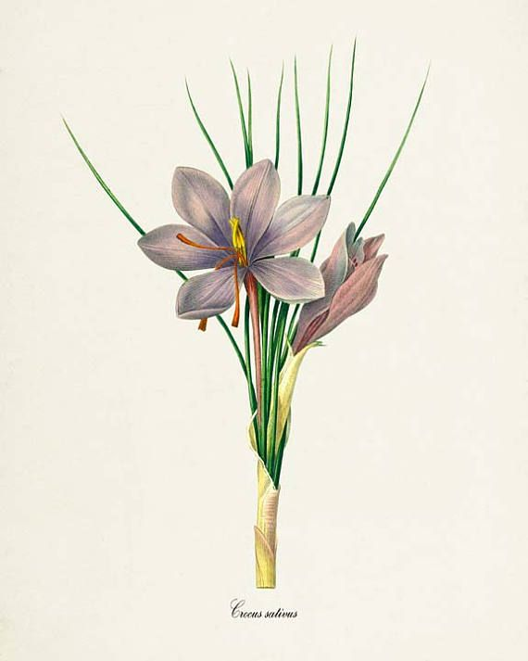

**Root** :- 1. In saffron, structurally and functionally there are two different types of roots.

**1. Absorbing (fibrous) roots** :- The fibrous roots are form from the base of each corm. It absorb water and nutrients. **2. Contractile roots** :- The contractile roots are usually tuber, fleshy and white in colour pull the plants deeper into the soil. **Stem** :- 1. It grows upto 15 cm. 2. The flowering plants are 20 – 30 cm. in height. **Leaves** :- 1. The plant gives rise 5 – 11 white and non – [photosynthetic](https://en.wikipedia.org/wiki/Photosynthesis) leaves known as [cataphylls](https://en.wikipedia.org/wiki/Cataphyll). 2. In spring, the plant true leaves are up to 40 cm. in length. 3. The leaves are grass like long and thin. 4. The leaf has a white central stripe along the leaf axis. 5. The leaf matgin is entire. **Inflorescence/Flower** :- 1. The membrane – like cataphylls cover and protect 5 – 11 true leaves as they bud and develop on the crocus flower. 2. The flower – bearing structures, bear specialised leaves, that arise from the flower stems the latter are known as [pedicels](https://en.wikipedia.org/wiki/Pedicel_(botany)). 3. The flowers are cup – shaped, soliatary, tapers off into a narrow tube. 4. The flowers are a light shade of lilac (light purple) to a darker and more stripped shiny pink colour. 5. The flowers possess a sweet, honey – like fragrance. 6. The flowering plants bear up to four flowers. 7. The flowers are of blue – violet colour. 8. A three – pronged (divided) [style](https://en.wikipedia.org/wiki/Style_(botany)) emerges from each flower. 9. Each prong terminates with a orange [stigma](https://en.wikipedia.org/wiki/Stigma_(botany)), which are the distal end of a [carpel](https://en.wikipedia.org/wiki/Carpel).

**CULTIVATION/PLANTING** 1. The purple flowers of saffron fail to produce seeds. 2. So the underground, bulb – like, starch – storing organs, which are clusters of [corms](https://en.wikipedia.org/wiki/Corm) must be dug up. 3. These corms are divided, and replanted. 4. The corms should be planted about 3 – 4 cm. deep in heavy soil. 5. A corm survives for one season, produce up to ten "cormlets" by vegetative division. 6. These cormlets can grow into new plants in the next season. 7. Fields that slope towards the sunlight are best. 8. Planting is mostly done in June in northern hemisphere. 9. Its roots, stems, and leaves can develop between October and February. 10. The depth planting and the corm spacing, are effected with climate. 11. The deeper planted corms gives higher yield and quality saffron. 12. Irrigation is required if grown outside of moist environments. 13. Rain immediately boost up flowering and saffron yields. 14. The corms begin to bud in early autumn. In mid = autumn they start flowering. 15. All plants bloom within one or two weeks . 16. After the early morning, flowers quickly wilt as the day passes. 17. Stigmas are dried quickly upon extraction and sealed in airtight containers.

**HARVESTING** 1. The saffron flowers three stigmas are picked up by hand. 2. They are spread on trays, and dried over charcoal fires. 3. It can be crushed to a fine powder in a mortar and pestle. 4. It is store in a cool dry place, out of the light. 5. For one pound of saffron, the 200,000 saffron stigmas are picked from 70,000 crocus flowers. 6. One freshly picked crocus flower yields an average 30 mg. of fresh saffron or 7 mg. dried saffron. 7. Roughly 150 flowers yield 1 gm. of dry saffron. 8. For 12 gm. of dried saffron, 45 kg. flowers are needed.

**ECOLOGICAL FACTOR Climate** :- 1. It grows in climates where hot and dry summer breezes (light wind) sweep semi – arid lands. 2. It can also survive in cold winters, tolerating severe cold as low as −10 °C. and short periods of snow cover. 3. It need average annual rainfall 39 – 59  inches. 4. The plants grow best in full sunlight. 5. The plant is poor in shady condition. **Soil** :- It grows well on friable (easily breakable), loose, low – density, well – watered, and well – drained, clay – [calcareous](https://en.wikipedia.org/wiki/Calcareous) sandy soils with high organic content. **SOME VARIETIES OF SAFFRON**  1. Several varieties of fennel are cultivated throughout the world.  2. Some of the varieties are :- Saffron Choora, Saffron Bulbs, Kesar bulbs, Kesar Mongra, Kesar Laccha etc.

**USES** 1. It is chiefly used as a dyestuff (material to form colour). 2. It contributes a yellow – orange colouring to foods. 3. Saffron is used in dishes. 4. Rice (Pullao) are coloured with saffron. 5. It is also used as a colouring material in confectionery (sweet, cake, chocolate etc). 6. In foods, it is used as a spice for flavor agent. 7. Saffron has also been used as a fabric [dye](https://en.wikipedia.org/wiki/Dye), particularly in China and India, and in perfumery. 8. It is used for religious purposes and ceremonial occasions in India. 9. It has medicinal properties. 10. It is used for Asthma, Cough, Intestinal gas, Pain, Relieving cold etc. 11. Women use saffron for menstrual cramp and in premenstrual syndrome. 12. Men use it to prevent early orgasm and interfertility.

JANARDAN PRASAD SINGH VISTHAPIT MAHAVIDYALAYA, BALIDIH DEPARTMENT OF BOTANY