**C4 – CYCLE/HATCH AND SLACK PATHWAY** 1. Beside C**3** cycle, Further studies led to the establishment of another type of CO**2** reduction pathway. 2. This process was first given by M.D.Hatch and C.R.Slack. So it is also called Hatch and Slack cycle or Hatch and Slack pathway. 3. In this pathway/cycle, the first stable product is an Oxaloacetic acid/Oxaloacetate (OAA) (C**4**H**4**O**5**). 4. The OAA is a 4 – carbon compound, So this cycle is also called C**4**​ cycle. 5. In this pathway/cycle, the primary acceptor of the CO**2**  is Phosphenol Pyruvic Acid or Phosphenol Pyruvate (PEP) (C**3**H**5**O**6**P). 6. This C**4**  cycle occurs in the plants that are adapted to dry tropical region. Eg :- Grass, Maize, Sorghum, Sugarcane etc. 7. The anatomy of the C**4** plants leaves have different anatomy than C**3** plants leaves.

**ANATOMY OF C4 PLANT LEAVES** 1. The C**4** plant leaves shows the following characteristics :- 2. The anatomy of the leaves of the C**4** plants is also called Kranz anatomy. 3. The leaves have two types of cells:- I. BUNDLE SHEATH CELLS II. MESOPHYLL CELLS

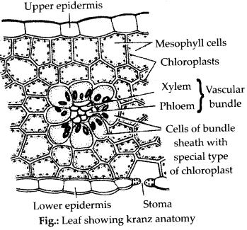 **I. BUNDLE SHEATH CELLS** 1. These cells are around the vascular bundle. 2. The layers of bundle sheath cells are surrounded by layer of mesophyll cells. 3. The chloroplasts of these cells are of larger size. 4. The grana is absent or undevelop here. 5. The PS – II is absent here. 6. The CO**2** released from here by the Malic acid/Malate (C**4**H**6**O**5**) is accepted by RuBP (C**5**H**12**O**11**P**2**). **II. MESOPHYLL CELLS** 1. These cells are around the bundle sheath cells. 2. The chloroplasts of these cells are of smaller size. 3. The grana are fully developed. 4. The PS – II is present here. 5. The enzymes of C**3** cycle is absent here. 6. The fixation of CO**2** takes place in cytoplasm. 7. Here the atmospheric CO**2**  is accepted by PEP (Phosphenol Pyruvic Acid/Phosphenol Pyruvate), which is a 3 – carbon compound.

**REACTIONS OF C4 CYCLE** 1. The C**4** cycle involves in two carboxylic reactions. 2. One taking place in the chloroplast of mesophyll cells and another takes place in the chloroplast of bundle sheath cells. 3. In this way, In C**4** plants the fixation of CO**2** takes place twice :- I. INITIAL FIXATION II. FINAL FIXATION

**I. INITIAL FIXATION** 1. In the chloroplast of mesophyll cells of C**4** plant leaves, there is a presence of PEP (Phosphenol Pyruvic Acid/Phosphenol Pyruvate), which is a 3 – carbon compound. 2. This PEP primarily accepts the CO**2**. 3. After that the stages of C**4** cycle can be summerised (described) in the following steps. **Step – I** :- **Carboxylation of Phosphenol Pyruvic Acid (PEP) and formation of Oxaloacetic acid (Oxaloacetate/OAA)** :- The 1st step involves the carboxylation of Phosphenol Pyruvic Acid (PEP) in chloroplast of mesophyll cells. The PEP accepts CO**2**  in the presence of water. This reaction is catalysed by Phosphenol Pyruvate Carboxylase (PEP Carboxylase/Pepco). The product of this reaction is Oxaloacetic acid (OAA) and Phosphoric acid (H**3**PO**4**).

Pepco PEP + CO2 + H2O OAA + H3PO4

**Step – II** :- **Equilibrium of Oxaloacetic acid (OAA) with Asparatic acid (Asparatate) and Malic acid (Malate)** :- The Oxaloacetic acid (OAA) equiliberate rapidly with other C**4** dicarboxylics acids. The Oxaloacetic acid makes the Asparatate (C**4**H**7**NO**4**) and Malate in the presence of enzyme transaminase and malate dehydrogenase respectively.

Transaminase Malate dehydrogenase Asparatate Oxaloacetate Malate

NADP+ + H+ NADP+

**II. FINAL FIXATION Step – III** :- **Transfer of Malate (Malic acid) from chloroplast of mesophyll cells to the chloroplast of bundle sheath cells** :- The malate in the chloroplast of mesophyll cells are transferred to the chloroplast of bundle sheath cells. Here it is decarboxylated to form CO**2**  and Pyruvic acid/Pyruvate (C**3**H**4**O**3**) in the presence of NADP and malic enzyme.

Malic enzyme Malic acid + NADP Pyruvic acid + CO2 + NADPH+

Now the CO**2**  is accepted by the PGA (Phosphoglyceric acid/Phosphoglyceraldehyde) in the chloroplast of bundle sheath cells and regulates the Calvin cycle (C**3** cycle).

**Step – IV** :- **Transfer of Pyruvate (Pyruvic acid) from bundle sheath cells to mesophyll cells and its Phosphorylation** :- The Pyruvic acid produced in the bundle sheath cells in Step – III are transferred to the chloroplast of mesophyll cells. Here the Pyruvic acid is phosphorylated. The Pyruvic acid reacts with ATP to form PEP (Phosphenol Pyruvate). This reaction is catalysed by an enzyme Pyruvate phosphate dikinase.

Pyruvate phosphate dikinase. Pyruvic acid + ATP + ip PEP + AMP + PPi

Now the PEP (Phosphenol Pyruvate) will again accept CO**2**  in the chloroplast of mesophyll cells and regulates the C**4** cycle again.

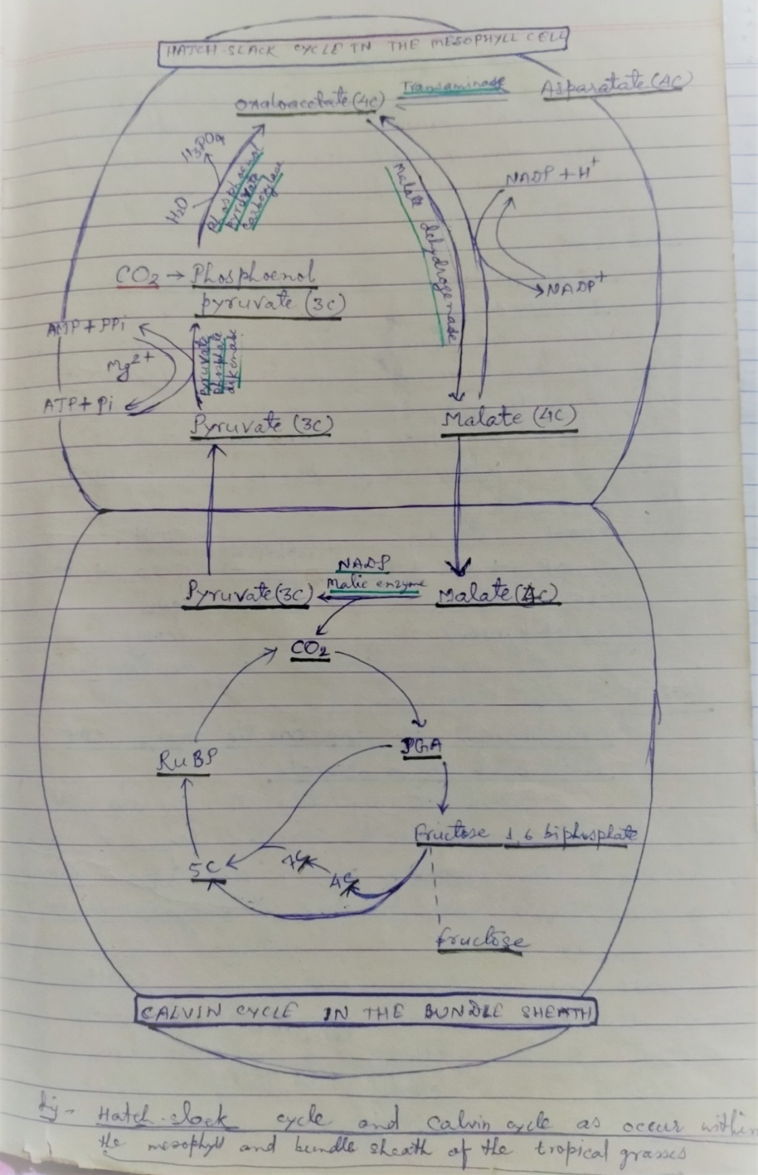

JANARDAN PRASAD SINGH DEPARTMENT OF BOTANY VISTHAPIT MAHAVIDYALAYA,BALIDIH