**CELL CYCLE AND CELL DIVISION CELL CYCLE** 1. It is a orderly series of changes in a cell. 2. A mature cell duplicates its contents, such as DNA, nucleus, cytoplasm, cell-organelles etc. and forms two cell by division. 3. So a time taken by a cell from its formation to maturation upto the time completing its division is called cell cycle. 4. This cell cycle was briefly studied by Howard and Pelk (1953). **CELL DIVISION/CELL REPRODUCTION** 1. The formation of new cells from the mother or primitive cell is called cell division or cell reproduction. 2. The cell which divides is called is called mother or parent cell. 3. The new formed cells by the division of mother cell are called daughter cells. 4. Hence a population of cells are formed by a parent cell. 5. So a multicellular individual is formed by a unicellular cell. **IMPORTANCE OF CELL DIVISION/REPRODUCTION I. CELLS FROM CELLS** :- All new cells are formed by the primitive cells through cell division. **II. NEW ORGANISM** :- The life of new organism begins with the cell division of the unicellular cell. Eg :- Fertilized egg or zygote. **III. GROWTH** :- The number of cell increases due to the continuous division in a unicellular cell. It forms the multicellular organism. **IV. REPLACEMENT** :- A large number of cells in multicellular are being destroyed through skin peeling, death of old RBC’s etc. These cells are replaced by new cells. **V. HEALING** :- An injury/wound is healed by the new cells produced by healthy cells around this through the cell division. **VI. REPRODUCTION** :- It is a mode of multiplication in unicellular organisms. In multicellular organisms, cell reproduction is essential for zygote formation.

**PHASES OF CELL CYCLE** The cell cycle completes in two phases :- I. INTERPHASE/I – PHASE II. MITOTIC/M – PHASE

Both these phases have several sub-phages :-

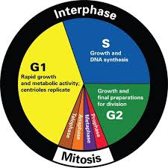

**I. INTERPHASE/I – PHASE** :- 1. It is the former phase of cell division or it can be said that it is a phase between two mitotic. 2. In this phase, the cell is at rest and prepare itself for cell division. 3. So it is called resting phase. 4. So the period occupied by a cell between cytokinesis & the beginning of next prophase is called interphase. 5. It is the important time of cell because of metabolic reaction both in nucleus and cytoplasm, marked by DNA replication. 6. This interphase has following sub-phases in a sequence :- i. G1 Phase/1st growth phase/Post mitotic phase/Pre synthetic phase. ii. S – phase/Synthetic phase of DNA. iii. G2 Phase/2nd growth phase/Pre mitotic phase/Post synthetic phase.

**i. G1 Phase (1st Growth phase)** It is the 1st phase of interphase which comes after cytokinesis. The RNA and protein is synthesized in this phase. The nucleus and the cell starts to increases in size. The formation of necessary cell organelles starts. This phase completes in 11 – 12 hours. **ii. S – phase (Synthetic phase of DNA)** The phase follows the G1 phase. The DNA synthesis begins in this phase. This phase completes in 6 – 8 hours. **iii. G2 Phase (2nd growth phase)** It is the 3rd phase of interphase which follows the S – phase. The synthesis of DNA stops at the end of this stage. cell and nucleus size increases. The synthesis of RNA and protein is continuous. Cell organelles also divides and the cell is ready for mitosis division. The chromosome are indistinct in this phase. Chromatins are thread like, coiled with each-other. This phase is of 3 – 4 hours.

**II. MITOTIC PHASE/M – PHASE** :- 1. The process of division begins in a cell after interphase. 2. Division may occur by mitosis or meiosis. 3. This phase separates the products of chromosome replicates or the chromosome are equally distributed into the daughter cells. 4. The cell organelles and the cytoplasm also divides. 5. The M – phase completes after two stages :- i. Karyokinesis/Nuclear division ii. Cytokinesis/Cytoplasm division

**TYPES OF CELL DIVISION** Generally the cell division is of two types :- I. MITOSIS II. MEIOSIS.

But a other type of cell division has also been reported in some cases known as amitosis.

**AMITOSIS :**- 1. The term amitosis was given by Fleming. 2. It is a direct method of cell division. 3. In it the nucleus 1st elongates, becomes dumble shaped and constrict from middle to divide into two parts. 4. The nuclear membrane do not disappears in this process. 5. The nuclear material divides into two unequal parts without the formation of spindle fibres. 6. The cytoplasm also divides after the division of nucleus. 7. The plasma membrane constrict and divides into two parts enclosing one nucleus each. 8. Hence two daughter cells are formed. 9. This type of division occurs in some fungi and in some algae. 10. In higher plants this type of division is found in the old cells which are in the process of disintegration.

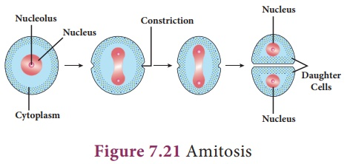

JANARDAN PRASAD SINGH DEPARTMENT OF BOTANY VISTHAPIT MAHAVIDYALAYA, BALIDIH