**MITOSIS** 1. It is a type of cell division in which a parent (mother) cell divides to form two daughter cells. 2. The daughter cells formed by the parent cell are genetically similar to the parent cell. 3. The number of chromosome in the daughter cells are same as the parent cell. 4. So the mitosis is also called equational/duplication division. 5. The division occurs for the formation or increase the number of somatic/vegetative cell. So also called somatic cell division. 6. The term mitosis was coined by Fleming (1882).

**DISCOVERY** The mitosis cell division in the plant cell was first studied by the strasburger (1870).

**OCCURRENCE**  1. The mitosis generally occurs during the growth in the somatic cells. 2. In plant cell, it occurs in the meristematic cell of the root apex, shoot apex etc. and in primary germ cells.

**STEPS OF MITOSIS**  The mitosis completes after two steps :- I. KARYOKINESIS/NUCLEAR DIVISION II. CYTOKINESIS/CYTOPLASMIC DIVISION **I. KARYOKINESIS**  1. It is a term used for nuclear division. 2. In mitosis, it is also called indirect nuclear division because nucleus disappears before division. 3. It completes after 4 – steps :- (A). PROPHASE (B). METAPHASE (C). ANAPHASE (D). TELOPHASE.

**(A). PROPHASE :-**  i. This is the 1st and longest stage of mitosis. ii. The chromatin fibres are condensed and forms the chromosome. iii. It can be divided into two sub-stages :- Early prophase and Late prophase. **Early Prophase** :- i. The chromatin fibres (threads) are shorten and condense to form the chromosome. ii. Each chromosome is made up of two thread like structures called chromatids. iii. The two chromatids are joined to one another at a point called centromere. iv. The nuclear membrane and nucleolus are clearly visible. **Late Prophase** :- i. The nuclear membrane, nucleolus and the cell-organelle starts to disappear. ii. The chromosome starts to move towards the middle of the cell. iii. The formation of spindle fibres starts from each pole.

**(B). METAPHASE**:- i. The nuclear membrane, nucleolus and the cell-organelle completely disappears. ii. The cytoplasm and nucleoplasm cannot be differentiated. iii. The chromosome are clearly visible. iv. The spindle fibres are completely formed which are attached with the centromere. v. The chromosome becomes short and condensed. vi. The chromosome are on the middle of the cell called equatorial/metaphase plate. vii. The centromere lies along the equator, while the arms of chromosomes extend free in any direction in the surrounding cytoplasm. viii. It is the shortest stage of mitosis.

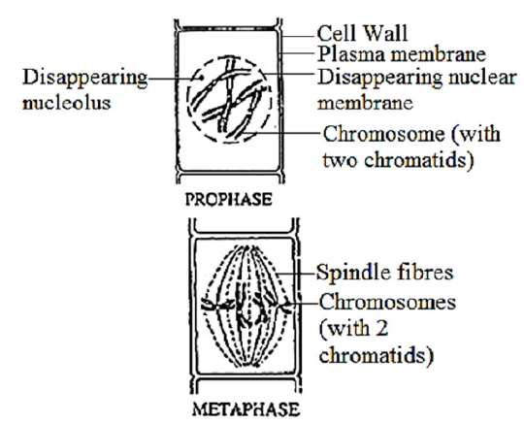

**(C). ANAPHASE** :- i. It is recognized by the separation of chromosomes and these starts to move towards the opposite pole. ii. The part of chromosome moving 1st is the centromere, which divides into two along with the chromosome. iii. As a result the parent chromosome divides into two daughter chromosome. iv. The spindle fibres starts to constrict, so daughter chromosome starts to move on opposite poles. v. There are two groups of chromosomes one at each pole.

**(D). TELOPHASE** :- i. The chromosomes are at the two poles in telophase. ii. This is just opposite of prophase. iii. The chromosomes in the poles becomes long, thin and invisible. iv. The spindle fibres disappears. v. The nuclear membrane and nucleolus appear in both poles. So two nucleus are formed in a cell. vi. The cell-organelle formation starts.

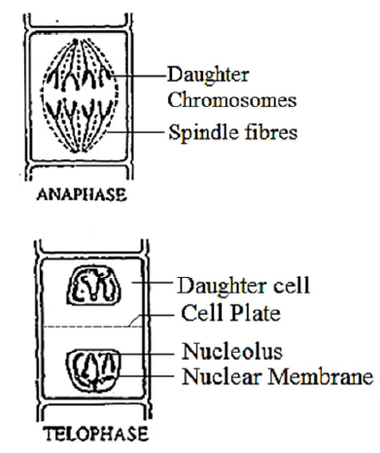

**II. CYTOKINESIS**  1. Them term is used for cell division. 2. The term completes just after telophase. 3. From this two daughter cells are formed. 4. These cells again grows and attains maturity.

**PROCESS OF CYTOKINESIS IN PLANT CELL**  1. The end of telophase coincides (occures at same time) with the division of cytoplasm of the daughter cells. 2. In plant cells, small droplets or granular bodies which are the products of golgi complex and microtubules gather in the equatorial region of the cell and forms the cell plate called phragmoplast. 3. The separation of the cytoplasm begins from the centre of the cell i.e. the cell plate is forms first in the middle of cell and grows gradually outwards on each side means towards the periphery from both sides and meet with mother cell. 4. So as a result two identical daudhter cells are formed. 5. The division is also called centrifugally.

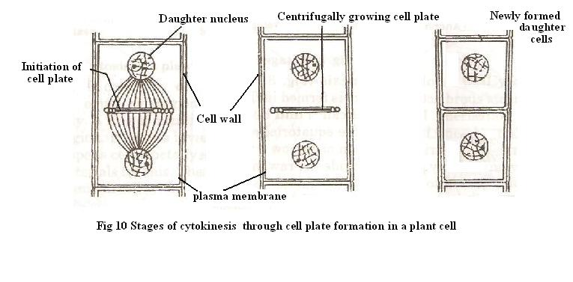

**SIGNIFICANCE OF MITOSIS**  **1. Cell division** :- Each cell divides to give rise to two daughter cells through mitosis. **2. Regeneration**:- The daughter cells formed after mitosis are similar to the parent cell in every respect. **3. Growth** :- It is essential for the growth and development in the multicellular organisms. **4. Maintenance of chromosome number** :- The number of chromosome remains similar in the daughter cells as in parent cell which are formed by mitosis.

JANARDAN PRASAD SINGH DEPARTMENT OF BOTANY VISTHAPIT MAHAVIDYALAYA, BALIDIH