**MEIOSIS/REDUCTION DIVISION**  1. The meiosis cell division is associated with the reproductive cells. 2. In plants, the male gametes and the female gametes are formed after meiosis. 3. In meiosis the cell divides twice, so 4 – cells are formed. 4. The number of chromosomes in the mother/parent cell (2n) becomes half after meiosis. 5. The daughter cells formed after meiosis from the parent cell have haploid (n) number of chromosome. 6. So it is also called reduction division. 7. During the gamete formation, the process was shown by Weismann (1887). 8. The term meiosis was first used by Farmer and Moore (1905).

**OCCURENCE**  1. It occurs in the diploid cells (2n). 2. The cell which undergoes the meiosis division are called meiocytes. 3. In plants, it occurs in the sporangium. 4. The cells of sporangium, which undergoes meiosis are called sporocytes.

**STEPS OF MEIOSIS**  There are two closely coordinated divisions which constitute the meiosis. So the meiosis completes after two steps. I. MEIOSIS – I/HETEROTYPIC DIVISION/REDUCTION DIVISION II. MEIOSIS – II/HOMOTYPIC DIVISION.

(**I). MEIOSIS – I :-** The meiosis 1st completes after two steps :- (A). KARYOKINESIS (B). CYTOKINESIS

**(A).KARYOKINESIS** :- It has 4 – stages :- 1. PROPHASE – I 2. METAPHASE – I 3. ANAPHASE – I 4. TELOPHASE – I

**1. PROPHASE – I** :- It is the 1st stage of meiosis. This stage is of longer duration. It is divided into 5 – sub-stages. **i. Leptotene** :- (a). It is the 1st stage of meiosis – I. (b). The size of the nucleus increases in this stage. (c). The chromosomes are thin, thread like and interwoven called chromonemata. (d). Half of the chromosome are of male parent and the other half of female parent. (e). The chromosomes carrying similar characters are called homologous chromosomes. (f). The chromosomes shows some swollen areas called chromomere.

**ii. Zygotene** :- (a). The homologous chromosomes starts pairing. The process is called synapsis. (b). The paired chromosome are called bivalent or dyad. (c). The synapsis occurs by the following methods :- **(a). Procentric synapsis** :- The pairing between the chromosomes starts from the centromere and goes towards the end. **(b). Proterminal synapsis** :- The pairing between the chromosomes starts from the one end and goes towards the end. **(c). Localised/Random synapsis** :- The pairing between the chromosomes starts at more than one point and goes towards the remaining part. **iii. Pachytene** :- (a). The bivalent chromosome becomes short and condensed. (b). Each chromosome divides longitudinally into two chromatids but remain attach at centromere. (c). So four chromatids are formed by a bivalent called called tetrad. (d). The two chromatids of each bivalent remain attach at one or more place called chaisma (Pl. chaismata). (e). The crossing over occurs at chaisma. **iv. Diplotene** :- (a). This sub-stage starts during pachytene at the time of tetrad formation. (b). The force of attraction between the homologous chromosomes lessen, and they starts separating. (c). The separating chromosomes do not separates completely and remains attach at one or more points called chaismata (Sing. chaisma). (d). Here two of the four chromatids are involved in exchange of segments called crossing over. (e). The nuclear membrane and the nucleolus starts disappearing. **(v). Diakinesis** :- (a). It is the last sub-stage of prophase – I. (b). The bivalent chromosome becomes short and condensed. (c). The nuclear membrane and the nucleolus disappear. (d). Spindle fibre formation starts. (e). The chaisma disappear.

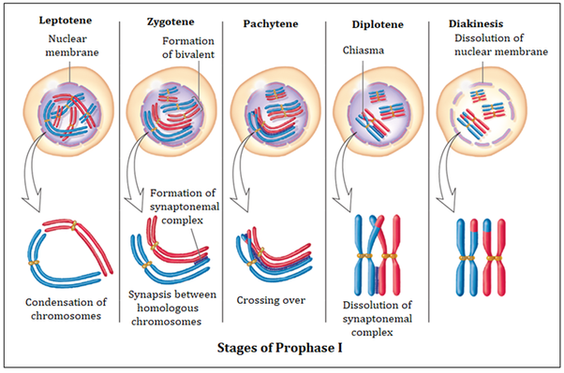

**2. METAPHASE – I** :- i. The bivalent chromosome are in the equatorial plate of the cell. ii. Each bivalent chromosomes centromere are attached with the centromere.

**3. ANAPHASE – I** :- i. This phase begins with the movement of chromosomes to the opposite poles. ii. The original centromere regions of the chromosome do not separate so each of the chromosome moves to an opposite poles. iii. The spindle fibre starts to constrict, so the homologous chromosome starts separating. iv. This is the period of reduction in chromosome number, because each group of moving chromosome is half the original number present in the nucleus. v. Each chromosome can be seen to consist of two distinctly separate chromatids united only at their centromeres.

**4. TELOPHASE – I** :- i. As the chromosomes reaches to the poles, the telophase – I starts. ii. The nuclear membrane and the nucleolus arises at each pole. iii. The nuclear membrane covers the haploid chromosome.

In this way during meiosis – I, a nucleus divides into two daughter nuclei havig the haploid number of chromosome.

**(B). CYTOKINESIS** :- 1. It starts after the end of telophase – I. 2. The cell divides by cell plate method and forms two daughter cell. 3. Each cell is haploid. 4. In cell plate method or plant cell cytokinesis several small particles accumulates in the middle of the cell. 5. These particles are made up of spindles and microtubules. 6. These spindles and microtubules particles connects and forms a plate called cell plate or phragmoplast. 7. The plate grows from middle to periphery from both ends and meets with mother cell. 8. As a result two daughter cells are formed in meiosis – 1. 9. This method of division is also called centrifugally.

**(II). MEIOSIS – II :-** In this division the two daughter cells produced by meiosis – I, divide like simple mitosis. So the number of chromosome remain same. The two chromatid of each chromosome separates to balance genetically. The meiosis – II may begin almost as soon as meiosis – I is complete. It completes after 2 – stages :- (A). KARYOKINESIS and (B). CYTOKINESIS.

**(A). KARYOKINESIS** :- The karyokinesis has 4 – stages :- 1. PROPHASE – II 2. METAPHASE – II 3. ANAPHASE – II 4. TELOPHASE – II

**1. PROPHASE – II** i. This stage is simpler than prophase – I. ii. The nucleus becomes clear and the two chromatids of chromosome are separated from each other except at centromere. iii. The nuclear membrane disappears.

**2. METAPHASE – II** i. All chromosome reaches equatorial plate and a spindle fibre is produced. ii. The centromere lies along the equator and the arms extended outward towards poles. iii. The two chromatids of a chromosome separate apart at centromere.

**3. ANAPHASE – II** i. The daughter chromosomes (the chromatids of preceding stage) move to opposite poles in this stage.

**4. TELOPHASE – II**  i. The daughter chromosomes reaches to opposite poles. ii. The nuclear membrane appears covering the chromosomes in each pole.

**(B). CYTOKINESIS :**- 1. As the telophase – II ends, the cytokinesis follows it. 2. Both the cells formed by meiosis – I, after passing through karyokinesis undergoes cytokinesis. 3. Finally four meiotic products are separated by cytokinesis. 4. The result of two meiotic divisions is therefore a quartet of cells. 5. Each cell contains the haploid number of chromosomes.

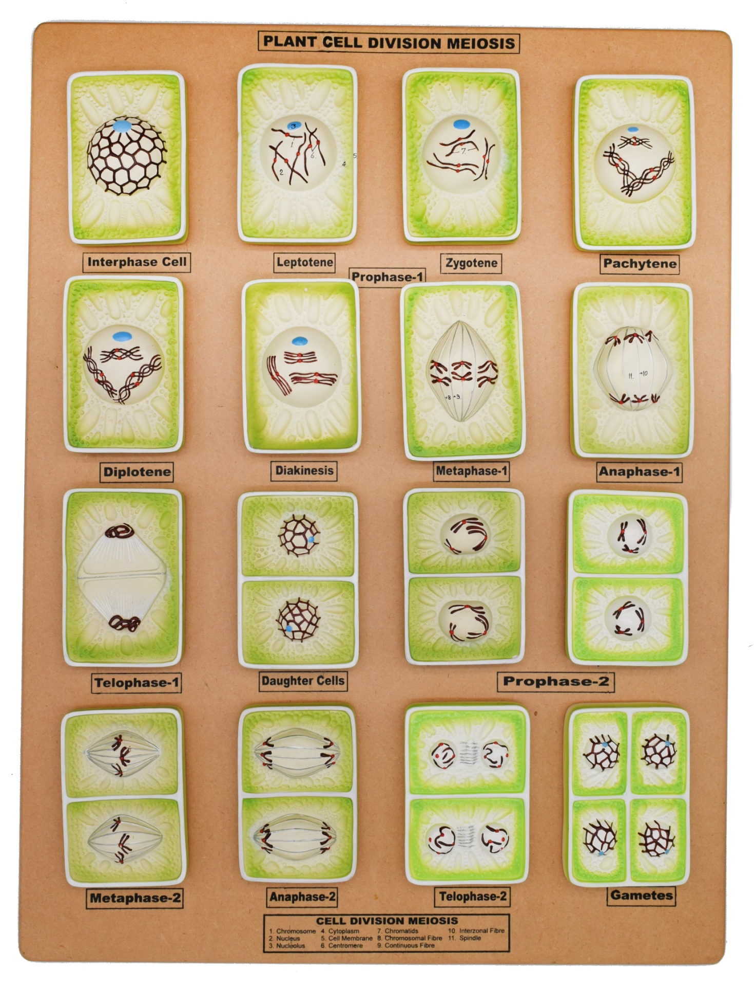

**TYPES OF MEIOSIS**  There are three types of meiosis based on the variations in time of place meiosis in the life cycle of different eukaryotic organisms :-

**I. ZYGOTIC OR INITIAL MEIOSIS (HAPLOTONIC PATTERN)** :- 1. At fertilization gametes fuse to form zygote which is the only diploid stage in life cycle. 2. The zygote immediately enters meiosis forming four haploid cells. 3. These cells germinate to give rise to haploid individuals. Eg :- Thallophyta.

**II. GAMETIC OR TERMINAL MEIOSIS (DIPLOTONIC PATTERN)** :- 1. This type of meiosis occurs in few lower plants. 2. In this case meiotic division occurs immediately before gamete formation. 3. Due to this meiosis the cells are transformed directly into male and female gamete without further cell division.

**III. SPORIC OR INTERMEDIATE MEIOSIS (DIPLOHAPLONTIC PATTERN)** :- 1. This type of meiosis takes place in higher plants and in some thallophyta. 2. In these there is alternation between haploid and diploid generations. 3. Fertilization produces the diploid sporophyte generation. 4. At some point meiosis occurs in sporophyte producing spores in place of gametes. 5. These spores on germination forms gametophytes. 6. Certain cells of the gametophyte form gametes. 7. Fusion of gametes return the cycle to diploid sporophytic generation.

**SIGNIFICANCE OF MEIOSIS**  1. The four cells (gametes) formed as a result of meiosis have got half number of chromosomes from the parent cell (2n). 2. It is essential for sexual reproduction because in this the gametes are formed which fuses to form the zygote. 3. The zygote gives rise to new diploid body. 4. During meiosis – I, although number of chromosome are reduced to half but at diplotene stage crossing over takes place. 5. Due to crossing over recombinants are formed.

JANARDAN PRASAD SINGH DEPARTMENT OF BOTANY VISTHAPIT MAHAVIDYALAYA, BALIDIH