**UNIT :- 4 BEVERAGES**

1. Beverages have always found in the place of pride in almost all the societies. 2. A  beverage (drink)  is a  [liquid](https://en.wikipedia.org/wiki/Liquid)   for  consumption. 3. It play an important roles in human  [culture](https://en.wikipedia.org/wiki/Culture). 4. The common types of beverages are [drinking water](https://en.wikipedia.org/wiki/Drinking_water), [milk](https://en.wikipedia.org/wiki/Milk), [coffee](https://en.wikipedia.org/wiki/Coffee), [tea](https://en.wikipedia.org/wiki/Tea), [hot chocolate](https://en.wikipedia.org/wiki/Hot_chocolate), [juice](https://en.wikipedia.org/wiki/Juice), [soft drinks](https://en.wikipedia.org/wiki/Soft_drink) and the [alcoholic drinks](https://en.wikipedia.org/wiki/Alcoholic_drink). Such as  [wine](https://en.wikipedia.org/wiki/Wine), [beer](https://en.wikipedia.org/wiki/Beer), and  [liquor](https://en.wikipedia.org/wiki/Liquor).

**TYPES/CLASSIFICATION OF BEVERAGES** The **beverages are of two types I. ALCOHOLIC BEVERAGE II. NON – ALCOHOLIC BEVERAGE**

**I. ALCOHOLIC BEVERAGE** 1. Alcoholic beverage is portable (easily carried) liquid containing liquor. They are derived from cereals and fruits like grapes etc. 2. They are produced by the introduction of yeast for fermentation into substance. Such as fruits, cereal (grain) and plant extract. 3. Generally, it is known as ethyl alcohol which is formed by a chemical reaction. 4. In this the yeast converts the glucose of the cereals into alcohol. 5. Alcoholic beverage has been divided into two categories, they are as follow :- A. FERMENTED ALCOHOLIC BEVERAGE/FERMENTED BEVERAGE B. DISTILLED ALCOHOLIC BEVERAGE/DISTILLED BEVERAGE

**A. FERMENTED BEVERAGES** Fermented Alcoholic beverages are classified into two :-  i. Wine ii. Beer.

**i. Wine** :- It is a beverage that is prepared by fermentation of Grape (Or other fruits like Cherry, Apricots, Pears, etc) by the addition of yeast. **ii. Beer** :- It is a beverage that is prepared by the fermentation of grain with yeast with the addition of Hops (a plant hindi name Rajak). These are generally called fermented malt beverages.

**B. DISTILLED BEVERAGES** i. A distilled beverage, spirit, soft liquor, or hard liquor is an alcoholic beverage produced by distillation of a mixture produced from alcoholic fermentation. Such as wine. ii. The beverages are distilled using either a Pot Still or a Patent Still. iii. Distilled beverages are alcohol (Rum, Whisky/ Whiskey, Vodka, Gin, Brandy, Tequila). iv. They are also called spirits. v. Flavoured and Sweetened spirits are called Liquours.

**II. NON ALCOHOLIC BEVERAGE 1.** Non-alcoholic beverage are non-intoxication drinks or soft drinks. 2. They are prepared from a number of plants. 3. They doesn’t have a bit of liquor (alcohol). 4. The yeast is not introduced here to convert sugar into alcohol during fermentation. 5. They are considering as soft beverages, which can be have according to the choice and standard. Eg :- aerated water, mineral water, juices, squashes, syrups, tea, coffee, milk etc. 6. It is widely used for diluting spirits with soft and cold drinks, alcoholic beverages etc. 7. It not only adds to the taste on it but also enhances colour & flavour and eye appeal. 8. In this the caffeinaceous (tea, coffee) are very popular. 9. They are consumed all over the world. 10. Coffee and Tea are the popular items of international trade.

JANARDAN PRASAD SINGH VISTHAPIT MAHAVIDYALAYA, BALIDIH DEPARTMENT OF BOTANY

**TEA**  Vernacular name :- Chai Botanical name :- [Camellia sinensis](https://en.wikipedia.org/wiki/Camellia_sinensis) **CLASSIFICATION** Class :- Eudicots Order :- Ericales Family :- Theaceae Genus :- Camellia species :- sinensis

1. Tea  is the popular and aromatic beverage. 2. It is an  [evergreen](https://en.wikipedia.org/wiki/Evergreen)  [shrub](https://en.wikipedia.org/wiki/Shrub). 3. It is a widely consumed drink in the world. 4. There are many different types of tea. Some like  [Darjeeling](https://en.wikipedia.org/wiki/Darjeeling_tea)  and  [Chinese greens](https://en.wikipedia.org/wiki/Green_tea). 5. Tea is a dried leaf of a bushy plant and contain Theine and Caffeine. 6. It is commonly prepared when over curl tea leaves are added to boiling water, it gives an aromatic and [stimulating](https://en.wikipedia.org/wiki/Stimulant) beverage due to its  [caffeine](https://en.wikipedia.org/wiki/Caffeine)  content. 7. It is one of the most important beverage in India. 8. It is popularly known as Chai.

**DISTRIBUTION/OCCURRENCE** 1. It is believed to be native to [South – west China](https://en.wikipedia.org/wiki/Southwest_China), North – eastern India (Assam) and the adjoining areas of upper Burma.  2. It grows mainly in  [tropical](https://en.wikipedia.org/wiki/Tropical_climate)  and  [subtropical](https://en.wikipedia.org/wiki/Subtropics)  climates. 3. The chief tea growing regions are all situated in Asia and some other tea cultivating countries are England, United States, Canada, Australia, New Zealand etc. 4. In Asia, the tea growing countries are China, Japan, Taiwan, Java, Bangladesh, India and Sri Lanka. 5. India and Sri Lanka are the world’s largest two tea producers and produces the two – thirds of the world’s total exports of tea. 6. In India, tea is cultivated in Assam, Kerala, Dehradun, Kangra, Darjeeling, Tarai, Meghalaya, Niligiri hills, Northern districts of Bengal, Kumaon districts, Ranchi etc.

**NUTRITION**  1. The tea is a rich source of fat, vitamin C and antioxidant. 2. It also contain some minerals. Such as Zinc, Magnesium, Magnese, Potassium, Calcium, Aluminum etc.

**BOTANICAL DESCRIPTION/STRUCTURE** It  is an  [evergreen](https://en.wikipedia.org/wiki/Evergreen)  tree or shrub.

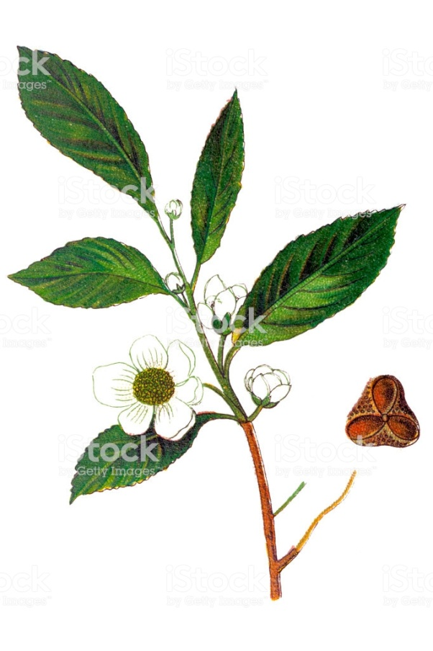 **Root** :- 1. The root system of tea comprises of two types of roots :- **i. Feeding roots** :- The feeding roots of tea are much branched . **ii. Extension roots** :- The young roots of tea are white and as they get older the colour of the roots changes to cream and finally to reddish – brown are called extension roots. 2. The depth of thicker roots depends largely on local conditions of the soil, rainfall and its distribution.   **Stem** :- 1. A tea plant grow into a tree of up to 30 – 50 ft., if left undisturbed. 2. But plants are generally pruned down to a small height of 2 – 5 ft. to plucking comfortably. 3. Also, the short plants bear more new shoots (branches) which provide new leaves and increase the quality of the tea and looks more like a shrub. **Leaves** :- 1. The development of leaves are slow. 2. They produce better-flavoured leaves. 3. The leaves are alternately arranged. 4. The leaves appear glossy (shining) dark green, elliptical in shape. 5. The margin is serrated. 6. They are glabrous (smooth) and petiolate. 7. The young leaves are however hairy. 8. The leaves contain numerous oil glands. 9. The mature leaves may be up to 12 inches in length. **Inflorescence/Flower** :- 1. The flowers are white and fragrant. 2. They are axillary, borne singly or in cluster of 2 – 4 together on short branches. **Fruit** :- 1. The fruit is 1 – 4 celled capsule. 2. The fruit is divided into chambers. 3. The chamber consist 1 – 3 seeds. **Seed** :- A plant takes about 4 – 12 years for seed production.

**CULTIVATION/PLANTING** 1. The tea is generally cultivated on hilly areas. 2. It can however be grown on flat plains in well drained soil. 3. Tea plants are propagated from seed and cuttings. **Nursery** :- 1. Tea is usually grown by sowing seeds. 2. The seeds are soaked in water overnight before sowing. 3. The seeds are sown in well prepared nursery beds. 4. The nursery beds are usually shaded. 5. Seeds are sown 4 – 8 inches apart. 6. The nursery is manure till the seedling are 6 – 9 months old. **Preparation of land** :- 1. The land where the tea seedlings are to be planted is also prepared. 2. Land occupied by forest is best for tea plantation. 3. The forest at first completely cleared of trees and then ploughed to remove the roots etc. 4. The steep (abundant) slopes of hills are contour terraced (like stair). 5. Drains are usually dug along the slope to prevent soil erosion and waterlogging of the low land areas. 6. The size and number of drains vary according to the nature of soil and the amount of rainfall. **Planting of seeds** :-1.The seedlings are planted in holes dug 3 – 5 ft. 2. The land should be terraced or flat depends upon the weather. 3. Organic manure is mixed with the soil for filling the holes. **Weeding** :- The weeds are prevented from growing along with the tea plantation by scraping the soil surface. **Pruning** :- 1. It is done for three purposes. (i). For profusely growth of the tea plant for development of new shoots. (ii). For ensure a continuous supply of tea leaves to the tea industry. (iii). For keeping the height of the plant low, so that the leaves can be plucked by hands. 2. When the plants are 2 – 5 years old, the 1st few pruning are done. 3. The pruning are usually of two types :- (i). Light pruning :- It is done annually or biennially. (ii). Heavy or Medium pruning :- It is done after 10 years. In this the plant is cut back to the ground level, so that the suckers replace the old bush. **Plucking** :- 1. Only the top 1–2 inches of the mature plant are picked. 2. These buds and leaves are called 'flushes'.   3. A plant will grow a new flush every 7 – 15 days during the growing season. 4. It is started when the plant is 4 – 5 years old. 5. The quality of tea depends upon the age of the leaves because the tannin content varies with the age. 6. The terminal bud gives excellent quality of tea. 7. Plucking is normally done by hand by the women and children. 8. It may be done at intervals of 7 – 10 days, since the new shoot develops . 9. In cold climates, there is no plucking during winter months because the growth of the plants comes to stop. 10. In hotter regions, 25 – 30 plucking can be done in a year.

**PREPARATION OF TEA** 1. After picking, the leaves soon begin to  [wilt](https://en.wikipedia.org/wiki/Wilting)  and  [oxidize](https://en.wikipedia.org/wiki/Oxidation)  unless immediately dried. 2. An  [enzymatic oxidation](https://en.wikipedia.org/wiki/Enzymatic_oxidation)  reaction of the plant's by intracellular  [enzymes](https://en.wikipedia.org/wiki/Enzyme)  causes the leaves to turn progressively darker as their  [chlorophyll](https://en.wikipedia.org/wiki/Chlorophyll)  breaks down and  [tannins](https://en.wikipedia.org/wiki/Tannins_in_tea)  are released. 3. This darkening is stopped at a predetermined stage by heating, which deactivates the enzymes responsible. 4. Commercially four kinds of tea are prepared:- A. Black tea B. Green tea C. Oolong tea D. Letpet or Leppet tea. 5. Among these Black tea is most important of all. 6. The black tea is prepared by the following four methods :- **i. Withering** :-(a). The harvested leaves are withered for about 24 hours on a well ventilated shelves or racks in the factories. (b). The withering results in the lowering of water content of the leaves, which becomes soft. **ii. Rolling** :- (a). The withered leaves are sent to the rolling machines. (b). The several rolling and the breaking operations of these leaves damage the individual leaf cells. (c). So the juice and enzyme content of leave s are released and gets smeared (substance spread over to make smooth) with them. **iii. Fermantation** :- (a).The rolled curled tea leaves are spread out in cool, moist fermentation rooms. (b). They are usually covered to keep warm. (c). Very high temperature spoils the quality of tea. (d). The leaves allowed to ferment for 2 – 6 hours. (e). During this period the leaves change from green to bright reddish colour and becomes aromatic. **iv. Drying or Firing** :- (a). The fermented leaves are conveyed (passed) through air chamber at 130* F. for 30 – 40 minutes and at 192 – 200* F. a while in the end. (b). The leaves coming out are left with only 3 – 4% moisture. (c). The tea prepared in this manner mentioned above is graded into various kinds.

**ECOLOGICAL FACTOR Climate** :- 1. It grows mainly in  [tropical](https://en.wikipedia.org/wiki/Tropical_climate)  and  warm temperate climates. 2. Some varieties can also tolerate  [marine climates](https://en.wikipedia.org/wiki/Oceanic_climate). 3. It require at least 127 cm. (50 in) of rainfall a year and annual minimum rainfall of 60 inches. 4. Prolonged drought damages the tea crop. 5. The high temperature with rainfall is good for tea plant. 6. The optimum monthly temperature between 70* – 90* F. is excellent. 7. Temperature below 65* F. is not good for its growth. 8. Frost damages the crop. 9. Shady conditions are better than exposed situations. **Soil** :- 1. It prefer  [acidic soils](https://en.wikipedia.org/wiki/Soil_pH) (pH 5.2 – 5.6). 2. Well manure and humus rich deep soil are good for the plant. 3. It can also grown on poor soil also. 4. The soil usually ranges from the light sandy to stiff clayey soil. 5. The soil must be well drained.

**SOME VARIETIES OF TEA** 1. Two principal varieties of tea are used. 2. Wight (1962) has named the two important types of Tea plants :- **i. Camellia sinensis (chinese)** :- It is used mostly by Chinese. They have smaller size leaves. **ii. Camellia assamica (assamese)** :- It is used  mostly as Indian teas. They have larger size leaves. It is assumed that the small leaves, China tea gave rise to large leaves Assam tea.

**USES** 1. The tea contains a material Theine, which dissolve quickly in hot water and gives a refreshing and stimulating beverage. 2. It relieves from fatigue (tiedness). 3. It is a blood pressure and cholesterol lowering agent. 4. Tea is a useful addition when making glycerin soap. The texture and scent can help to make the soap dense better. 5. Drinking tea could help to reduce the risk of heart attack.

JANARDAN PRASAD SINGH VISTHAPIT MAHAVIDYALAYA, BALIDIH DEPARTMENT OF BOTANY