**PAPER – 13, UNIT – 1 CONCEPTS/INTRODUCTION OF METABOLISM**

1. The plant cells constantly carries out several chemical reactions in different form to keep the plant or the plant cell alive. These chemical reactions are often linked together in chains, or pathways. All of the chemical reactions occurring inside of a plant or plant cell is called metabolism. 2. In the metabolic process, some of the chemical reactions release energy and others add energy in order to take place. So the processes of making and breaking down glucose molecules are the examples of metabolic pathways. Plant metabolism is defined as the complex of physical and chemical events of photosynthesis, respiration, and the synthesis and degradation of organic compounds. 3. A  metabolic pathway  is a series of connected chemical reactions. The pathway takes place in one or more starting molecules and, through a series of intermediates, converts them into products. 4. The chemical reactions in metabolic pathways are always guided in each reaction step by a protein (catalyze) called an enzyme. 5. The three main purposes of metabolism are:- (i). The conversion of food to  [energy](https://en.wikipedia.org/wiki/Energy)  to run the cellular processes. (ii). The conversion of food to building blocks for  [proteins](https://en.wikipedia.org/wiki/Protein), [lipids](https://en.wikipedia.org/wiki/Lipid), [nucleic acids](https://en.wikipedia.org/wiki/Nucleic_acid), and some   [carbohydrates](https://en.wikipedia.org/wiki/Carbohydrate). (iii). The elimination of  [nitrogenous wastes](https://en.wikipedia.org/wiki/Metabolic_waste#Nitrogen_wastes) formed by the degradation of a organic compounds.

For example, Sugars like glucose are made by plants in a process called  [photosynthesis](https://www.khanacademy.org/science/biology/photosynthesis-in-plants/introduction-to-stages-of-photosynthesis/v/photosynthesis). In photosynthesis, plants use the energy of sunlight to convert carbon dioxide gas into sugar molecules (like glucose having chemical formula C6H12O6). They consume carbon dioxide and produce oxygen as a waste product. This reaction is summarized as :-

6CO2 + 6H2O –> C6H12O6 + 6O2

Photosynthesis takes place in many steps. During the light reactions of photosynthesis, energy is provided by a molecule called  adenosine triphosphate (ATP). 6. But its overall reaction is just the cellular respiration reaction flipped backwards. The plants need energy to power their cellular processes. So some of the sugars are used by the plant itself. The glucose will be broken down through cellular respiration, generating ATP to keep cells running. ATP which is stored in form of energy is an important molecule for cells to have in sufficient supply at all times. 7. Many cells get energy from glucose in a process called  [cellular respiration](https://www.khanacademy.org/science/biology/cellular-respiration-and-fermentation/intro-to-cellular-respiration/v/introduction-to-cellular-respiration). During this process, a glucose molecule is broken down gradually, in many small steps. 8. Breaking down of glucose releases energy, which is gained by the cell in the form of  ATP (adenosine triphosphate). This ATP can be used by other reactions in the cell as an energy source. Because of this, ATP is sometimes described as the “energy currency” of the cell. 9. The cells use molecules of ATP as energy to perform immediate work. In contrast, energy-storage molecules, Such as glucose are consumed only to be broken down to use their energy. The reaction that harvests the energy of a sugar molecule in cells requiring oxygen to survive can be summarized by the reverse reaction to photosynthesis. In this reaction, oxygen is consumed and carbon dioxide is released as a waste product. The reaction is summarized as :-

C6H12O6 + 6O2 –> 6H2O + 6CO2

10. The different metabolic pathways function in the compartment of the cell.  For example, (i). The  [electron transport chain](https://en.wikipedia.org/wiki/Electron_transport_chain), and  [oxidative phosphorylation](https://en.wikipedia.org/wiki/Oxidative_phosphorylation)  process take place in the mitochondrial membrane. (ii). The [glycolysis](https://en.wikipedia.org/wiki/Glycolysis), [pentose phosphate pathway](https://en.wikipedia.org/wiki/Pentose_phosphate_pathway), and  [fatty acid biosynthesis](https://en.wikipedia.org/wiki/Fatty_acid_synthesis)  all occur in the  [cytosol](https://en.wikipedia.org/wiki/Cytosol" \o "Cytosol) (cytoplasm) of a cell.

**TYPES OF METABOLISM/PATHWAY** Generally there are two types of metabolic pathways. The two pathways complement each other in that the energy released from one is used up by the other. I. ANABOLIC METABOLISM II. CATABOLIC METABOLISM

**I. ANABOLIC METABOLISM** 1. Anabolism is a biochemical process also called  biosynthesis . 2. It is the set of  [metabolic pathways](https://en.wikipedia.org/wiki/Metabolic_pathway)  where smaller units or simple molecules combines to construct larger and more complex compound  [molecules](https://en.wikipedia.org/wiki/Molecules) .  3. These reactions require  [energy](https://en.wikipedia.org/wiki/Energy), known also as an  [endergonic](https://en.wikipedia.org/wiki/Endergonic_reaction" \o "Endergonic reaction)  process. 4. It is the building-up aspect of  [metabolism](https://en.wikipedia.org/wiki/Metabolism). 5. These biosynthetic processes are critical to the life of the cell, take place constantly and use energy carried by ATP molecules and other high-energy molecules like NADH and NADPH.

**EXAMPLES OF ANABOLIC METABOLISM** 1. The processes of photosynthesis to form glucose molecules and oxygen are the examples of Anabolic metabolic pathways.

6CO2 + 6H2O → C6H12O6 + 6O2

In Anabolic pathway small molecules are assembled and the larger molecules are produced. For this energy is typically required.The formed glucose from carbon dioxide in the process cellular respiration.

2. The process of formation of  [disaccharides](https://byjus.com/chemistry/disaccharides/)  and water with the help of combining simple sugars.

C6H12O6 + C6H12O6 → C12H22O11 + H2O

3. The process of formation of dipeptides by combining Amino acids.

NH2CHRCOOH + NH2CHRCOOH → NH2CHRCONHCHRCOOH + H2O

4. The process of formation of lipids when glycerol reacts with fatty acids.

CH2OHCH(OH)CH2OH + C17H35COOH → CH2OHCH(OH) CH2OOCC17H35

5. Other examples include the synthesis of proteins from amino acids, or the DNA strands are formed by the nucleic acid building blocks (nucleotides). DNA (Deoxyribonucleic acid) is a macromolecule which is made up of smaller molecules known as  [nucleic acids](https://byjus.com/chemistry/nucleic-acids/). These nucleic acids are made up of a nucleotide base attached to a phosphate and deoxyribose sugar molecule. DNA synthesis takes place in the nucleus of the cell before cell division. It involves the following steps:- (i). Unzipping (opening) the double – stranded DNA. (ii). Attaching new matching nucleotides to each strand to form two new strands.

**STAGES OF ANABOLIC METABOLISM** There are three stages in anabolism. They are :- 1. Production of precursors (something develop) such as monosaccharides, nucleotides, amino acids, and isoprenoids (compound made of two or three units of hydrocarbon). 2. Activation of the above – mentioned precursors into reactive forms with the help of energy from ATP. 3. Assemble the precursors to form complex molecules, Such as polysaccharides, nucleic acids, proteins, and lipids.

**FUNCTION OF ANABOLIC METABOLISM** 1.The nutrients of food are broken down into small molecules in the catabolic pathway. In anabolic metabolism, these small molecules formed by the catabolic pathway are combined to form a large molecule or macromolecule. 2. During the anabolic pathway, energy is utilized to generate large molecules by forming chemical bonds between the smaller molecules. These macromolecules are further used to build new cells or structure of the cells. 3. Anabolism is essential for maintenance, growth, and development of a cell.

**II. CATABOLIC METABOLISM** 1. [Catabolism](https://en.wikipedia.org/wiki/Catabolism)  is the set of metabolic pathway that breakdown molecules into several smaller units, which are oxidized (electron lost) to release  [energy](https://en.wikipedia.org/wiki/Energy)  or used in other  [anabolic](https://en.wikipedia.org/wiki/Anabolic)  reactions. 2.  It breaks down large molecules, Such as  [polysaccharides](https://en.wikipedia.org/wiki/Polysaccharide), [lipids](https://en.wikipedia.org/wiki/Lipid), [nucleic acids](https://en.wikipedia.org/wiki/Nucleic_acid)  and  [proteins](https://en.wikipedia.org/wiki/Protein) into smaller units. Such as  [monosaccharides](https://en.wikipedia.org/wiki/Monosaccharide" \o "Monosaccharide), [fatty acids](https://en.wikipedia.org/wiki/Fatty_acid), [nucleotides](https://en.wikipedia.org/wiki/Nucleotide), and  [amino acids](https://en.wikipedia.org/wiki/Amino_acid), respectively. 3. Sometimes waste products are also generated, including carbon dioxide, urea, ammonia, acetic acid, and lactic acid

**EXAMPLES OF CATABOLIC METABOLISM** 1. The processes of breaking down of glucose molecules into several units is catabolic metabolic pathways. 2. In Catabolic pathway, large molecules are broken down into small ones. In this energy is typically released or it may be defined as Catabolic pathways  involve the breakdown of complex molecules into simpler ones and typically release energy. 3. The energy stored in the bonds of complex molecules, Such as glucose and fats, is released in catabolic pathways. 4. During cellular respiration, glucose and oxygen react to yield carbon dioxide and water.   
 C6H12O6 + 6O2  →  6CO2 + 6H2O 5. In cells, hydroxide peroxide (hydrogen peroxide) decomposes into water and oxygen:  
 2H2O2  →  2H2O + O2 6.Protein Catabolism :- All proteins in the known in the world are formed of the same 20 amino acids. That means that the proteins in plants are combinations of the 20 amino acids. When this protein is digested (breakdown) in the catabolism, the enzymes known as  proteinases  break the bonds between the amino acids in each protein, until the acids are completely separated. These separated amino acids will be recombined into new proteins.

Anabolic pathway: small molecules are assembled into larger ones. Energy is typically required.

Catabolic pathway: large molecules are broken down into small ones. Energy is typically released.

**AMPHIBOLIC METABOLISM/PATHWAYS** 1. The term  amphibolic  was proposed by  [B. Davis](https://en.wikipedia.org/w/index.php?title=B._Davis&action=edit&redlink=1)  in 1961 to emphasise (told) the dual metabolic role of such pathways. 2. An amphibolic pathway is one in which both catabolism and anabolism occurs. 3. During respiration glucose or other substrates are broken down to produce energy (catabolism). Certain substances, Such as fatty acids during their breakdown are converted to acetyl coenzym A before being broken down to generate energy. 4. This acetyl coenzyme A, however, can also be used for the synthesis of fatty acids. Synthesis of complex substances in this manner (from simple substances) is said to be anabolism. 5. Therefore, both catabolism and anabolism occur during respiration and can be said to be having an amphibolic pathway.

**EXAMPLES OF AMPHIBOLIC METABOLISM** 1. The glyoxylate cycle and the citric acid cycle are the examples of amphibolic pathways. These cycles can either produce energy or use it, depending on cellular needs. 2. All the reactions associated with synthesis of biomolecule converge into the following pathway, [glycolysis](https://en.wikipedia.org/wiki/Glycolysis" \o "Glycolysis), the Krebs cycle and the  [electron transport chain](https://en.wikipedia.org/wiki/Electron_transport_chain) (ETC), existing as an amphibolic pathway, meaning that they can function anabolically as well as catabolically. Other important amphibolic pathways are the  [Embden – Meyerh of pathway](https://en.wikipedia.org/wiki/Embden-Meyerhof_pathway" \o "Embden-Meyerhof pathway), the  [pentose phosphate pathway](https://en.wikipedia.org/wiki/Pentose_phosphate_pathway) (PPP). 3. Catabolism is a degradative phase of  [metabolism](https://en.wikipedia.org/wiki/Metabolism)  in which large molecules are converted into smaller and simpler molecules, which involves two types of reactions :-. **A. Hydrolysis reactions** :- It involve the breaking apart of molecules into smaller molecules to release energy. Examples of catabolic reactions are digestion and cellular respiration, where sugars and fats are broken down for energy. Breaking down a  [protein](https://en.wikipedia.org/wiki/Protein)  into  [amino acids](https://en.wikipedia.org/wiki/Amino_acid), or a  [triglyceride](https://en.wikipedia.org/wiki/Triglyceride)  into  [fatty acids](https://en.wikipedia.org/wiki/Fatty_acid), or a  [disaccharide](https://en.wikipedia.org/wiki/Disaccharide)  into  [monosaccharides](https://en.wikipedia.org/wiki/Monosaccharide" \o "Monosaccharide)  are all hydrolysis or catabolic reactions. **B. oxidation reactions** :- It involve the removal of hydrogens and electrons from an organic molecule. In this  anabolism is the constructive part of metabolism in which smaller simple precursors are converted to large and complex molecules of the cell. Anabolism has two classes of reactions :- (a). The first are dehydration synthesis reactions; these involve the joining of smaller molecules together to form larger, more complex molecules. These include the formation of carbohydrates, proteins, lipids and nucleic acids. (b). The second are reduction reactions, in which hydrogens and electrons are added to a molecule. Whenever that is done, molecules gain energy.

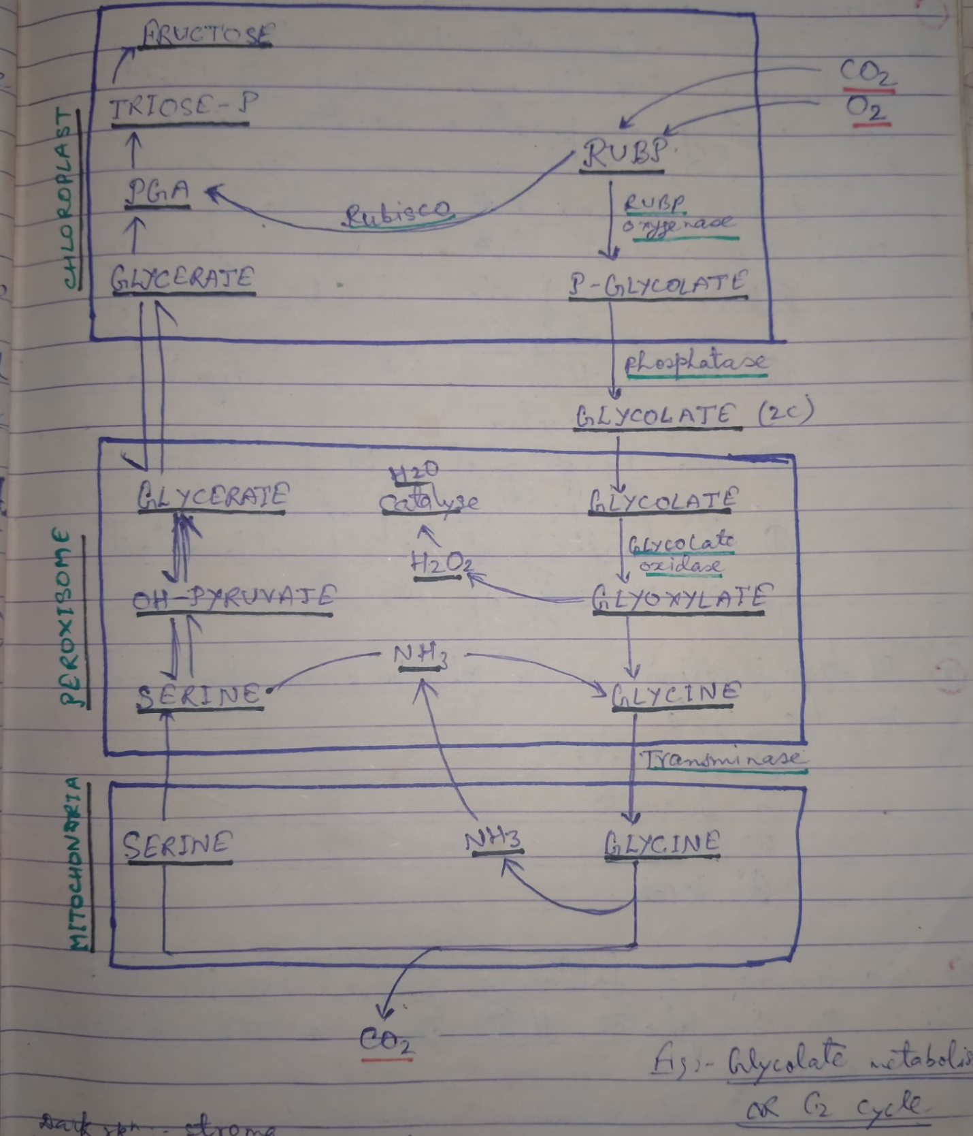

JANARDAN PRASAD SINGH VISTHAPIT MAHAVIDYALAYA, BALIDIH DEPARTMENT OF BOTANY