**NUCLEIC ACID**  1. Nucleic acid are the very important macromolecule. 2. These are present in all living organisms. 3. These are the important information molecules and they have the necessary genetic information required by living organisms for their survival. 4. They are also responsible for continuity for information in next generation. 5. The nucleic acids are the polymers of nucleotides. 6. The long chain of nucleotides are called polynucleotides. **NUCLEOTIDE**  A nucleotide is composed of following components :- I. Pentose Sugar II. Nitrogenous Base III. Phosphoric Acid

**I. PENTOSE SUGAR** 1. Pentose sugar is a 5– carbon sugar and it is called Ribose in RNA and Deoxy-ribose in DNA. 2. The Deoxy-ribose sugar has oxygen less than the Ribose sugar in the 2-carbon atom. 3. Both the types of sugar are shown in pentagoan ring with one oxygen and 4-carbon atoms in the ring. 4. The last (5-carbon atom) lies outside the ring. 5. Deoxy-ribose sugar is found in the nucleotide that forms DNA, while the ribose sugar is found in the nucleotide of RNA.

HOH**2**C OH HOH**2**C OH

H H H H

H H H H

OH OH OH H

Ribose Deoxy-ribose

fig :- The absence of -OH group at the 2 – carbon of Deoxy-ribose **II. NITROGENOUS BASE** These nitrogenous are heterocyclic compounds. These are of two types :- 1. Purine 2. Pyrimidine  **1. PURINE** :- i. These are the double ring compound. ii. In the ring 1, 3, 7 and 9 has the nitrogen in place of carbon.

NH2

C 6

N 1 5 C N 7

8 CH

HC 2 4 C

N 3 H

Fig :- Structure of purine

iii. It is of two types :- [A]. Adenine(A). [B]. Guanine(G)

**[A]. Adenine** (a). It is a purine derivative. (b). It is a six membered ring attached to five membered ring. (c). Its chemical formula is C**5**-H**5**-N**5**. (d). It has an additional point of unsaturation between 6-carbon or 1-nitrogen portions of its six membered ring. (e). Its structural formula is :-

NH**2**

C

N C N

CH

HC C N

N H

**[B]. Guanine** (a). It is a purine derivative. (b). It is a six membered ring attached to a five membered ring. (c). Its chemical formula is C**5**-H**5**-N**5**-O. (d). It has acidic or ketone group(C=O) attached to 2-C or 6-C positions of its six membered ring. (e). Its structural formula is :-

OH

C

N C N

CH

NH2 – C C N

N H

**2. PYRIMIDINE** i. These are single ring compound.ii. In the ring 1 & 3 has the nitrogen in place of carbon.

H

C 6

N 1 5 CH

HC 2 4 CH

N3

fig :- structure of pyrimidine iii. It is of three types :- [A]. Thymine(T) [B]. Cytosin(C) [C]. Uracil(U).

[A]. **Thymine**  (a). It is a pyrimidine derivative. (b). In RNA, thymine is replaced by uracil. (c). It chemical formula is C**5**H**6**N**2**O**2**. (d). Its structural formula is :-

OH

C

HN C CH3

HO C CH

N

**[B]. Cytosine** (a). It is a pyrimidine derivative. (b). Its chemical formula is C**4**H**5**N**3**O. (c). Its structural formula is :-

NH2

C

N CH

HO C CH

N

**Uracil**  (a). It ia a pyrimidine derivative. (b). In DNA, uracil is replaced by thymine. (c). Its chemical formula is C**4**H**4**N**2**O**2**. (d). Its structural formula is :-

OH

C

N CH

OH C CH

N

**III. PHOSPHORIC ACID** 1. It is also represented as phosphate group(PO**4**). 2. It provides the acid properties to nucleic acid. 3. Its chemical formula is H**3**PO**4**. 4. Its structural formula is :-

OH

O P OH

OH

**STRUCTURE AND FUNCTION OF NUCLEOTIDE**

**STRUCTURE OF NUCLEOTIDE** 1. The nucleic acids (DNA & RNA) are the polymers. 2. They are made up of monomers called mononucleotide units (MNU). 3. These mononucleotides are joined together. 4. The nucleotide unites themselves are made up of smaller types of components. 5. These components are of sugar, nitrogenous base (heterocyclic base) and phosphate.

**SUGAR** 1. It is a part of nucleotide. 2. It is a pentose ring form with 5-carbon atom. 3. It is in ribose form in RNA and deoxy-ribose in DNA. 4. The deoxy means that tha ribose molecule has lost an oxygen in the 2-carbon atom. 5. The last(5th) carbon lies outside the ring.

HOH**2**C OH HOH**2**C OH

H H H H

H H H H

OH OH OH H

Ribose Deoxy-ribose

fig :- The absence of -OH group at the 2 – carbon of Deoxy-ribose

**NITROGENOUS BASE** 1. Several types of bases are found in nucleotide. 2. These are heterocyclic bases or compounds because they contain nitrogen within the rings. 3. They are of two types :- I. Puirine II. Pyrimidine.

(Repeat from nucleic acid) **PHOSPHATE (PHOSPHORIC ACID)**

(Repeat from nucleic acid )

**FUNCTION OF NUCLEOTIDE** 1. They play major role in cellular metabolism. 2. They are the constituents of nucleic acids. 3. Nucleic acids are the molecular repositories (Store center) of genetic information. 4. The ability of nucleic acid is to store and transmit genetic information from one generation to the next. 5. Nucleotides are very essential for chemical links in the response of cells to hormones.

**TYPES OF NUCLEIC ACID** The nucleic acid are of two types :- I. DNA (Deoxy-ribonucleic acid) II. RNA (Ribonucleic acid).

**DNA (Deoxy-ribonucleic acid)_** 1. DNA is the genetic material of almost all organisms. 2. It is the main component of chromatin fibre. 3 . It is present in the nucleus of eukaryotes and the nucleoid region of prokaryotes. **STRUCTURE OF DNA** 1. DNA molecule consist of two polynucleotide chain. 2. These chains are coiled helically around each-other in such a way that the sugar and phosphate molecules remains outside and the nitrogenous bases are folded inside. 3. This structure is called double helix. 4. The two chains are held together by hydrogen bonds between specific pairs of Purines and pyrimidines. 5. In the DNA, four kinds of nucleotides are present. 6. They are :- i. Deoxy-adenosine monophosphate (dAMP) ii. Deoxy-guanosine monophosphate (dGMP) iii. Deoxy-cytidine monophosphate (dCMP) iv. Deoxy-thymidine monophosphate (dTMP).

**WATSON AND CRICK MODEL OF DNA** The DNA molecule structure was discovered by James Watson and Francis Crick. According to them, the structure can be understood as follows :- 1. DNA has two polynucleotide chain or strand. 2. These strand are helically coiled. 3. The helix are stable due to the presence of hydrogen bonds between the nitrogenous base. 4. The two strands of the DNA runs in opposite direction called anti-parallel. One at 3’ – 5’ & the other at 5’ – 3’ direction. A nucleotide can be added only at the 3’ end. So DNA synthesis will occur only in 5’ – 3’ direction. 5. The hydrogen bonds are formed between a Purine and a Pyrimidine. 6. Adenine(A) pairs with Thymine(T) and Cytosine(C) pairs with Guanine(G). 7. There are double hydrogen bond between A & T (A = T) and triple hydrogen bond between G & C (G = C). This is called complementary base pair. 8. A complete turn of helix pitch is 34 A* or 3.4 nm. 9. In a turn the number of nucleotide base pair are 10. 10. The distance between the two nucleotide base pair is 3.4 A* or 0.34 nm. 11. The width of the DNA is 20 A* or 2.0 nm.

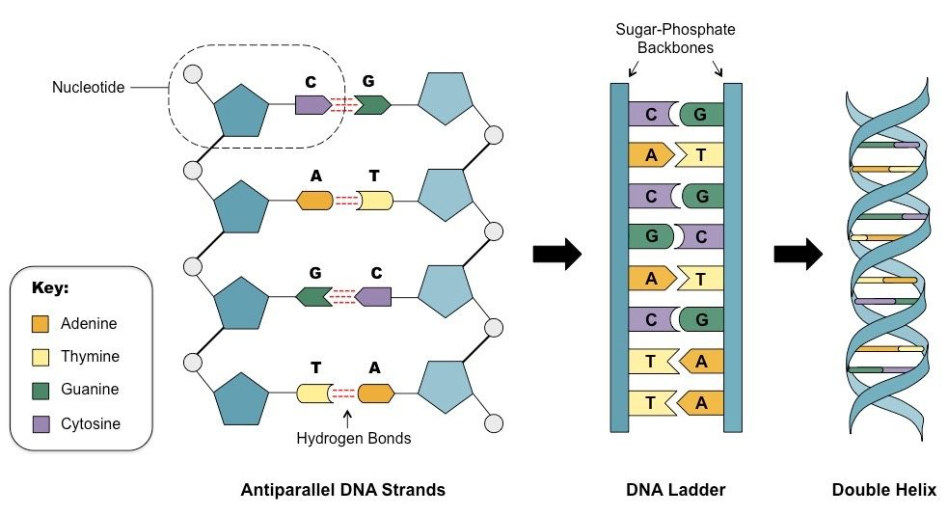

**RNA (Ribonucleic acid)** 1. RNA is mostly found in cytoplasm. 2. But it is the genetic material in some viruses and in some plants. **STRUCTURE OF RNA** 1. RNA molecule consist of a single polynucleotide chain or strand. 2. It contains ribose sugar. 3. In this the number of Purine and Pyrimidine ratio is not equivalent to one. 4. It has four nitrogenous bases :- i. Adenine(A) ii. Guanine(G) iii. Cytosine(C) iv. Uracil(U) 5. According to the nitrogenous bases, the nucleotides are of four types :- i. Adenosine mono phosphate (AMP) ii. Guanosine mono phosphate (GMP) iii. Cytosine mono phosphate (CMP) iv. Uracil mono phosphate (UMP)

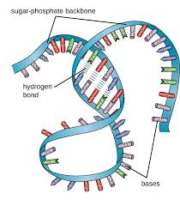 **TYPES OF RNA** There are three main types of RNA :- I. mRNA/messenger RNA II. tRNA/transfer RNA III. rRNA/ribosomal RNA  **I. mRNA** 1. This RNA has the message for the ribosome for the kind of protein that has to be synthesized. 2. It consist of about 5% of the total RNA. 3. It contains the message of the DNA in the form of specific nucleotide sequence. 4. A set of three bases are present for a specific amino acid called codon. 5. Different proteins are specified by different sequences of nucleotides. 6. It is also reffered as informational RNA or template RNA. **II. tRNA** 1. This RNA transfer the amino acid from the amino acid pool to the site of protein synthesis. 2. There are specific tRNA’s for specific amino acid. 3. This type constitutes of about 15% of the total RNA content. 4. It has also a set of three nitrogenous bases that are complementary to the codon in the mRNA. This is called anti-codon. **III. rRNA** 1. This RNA remains attached with the ribosome. 2. In ribosome, it attached at the site of protein synthesis place. 3. It constitutes of about 70 – 80% of the total RNA content.

**STRUCTURE OF B – DNA** The B – DNA is the most common & more in number in the cell. The important structural features of B – DNA are given below :- 1. Majority of the DNA in a cell is in B – DNA form. 2. It is a right handed helix. 3. In B – DNA, the nitrogenous bases are at the middle and the sugar and the phosphate occurs at the peripheral portion of helix. 4. Each base pair in B – DNA has same width. 5. The width of A – T and G – C in B – DNA is 10.85 A* 6. The helical diameter of B – DNA is 20 A* 7. Each turn in B – DNA is of 34 A* 8. Each turn in B – DNA consist of 10 base pairs. 9. The distance between the base pair of a turn in B – DNA is 3.4 A*

**COMPARISON OF B – DNA AND Z – DNA**

**CHARACTERS** **B – DNA** **Z – DNA** 1. Helix turn Right handed Left handed 2. Helical diameter 20 A* 18 A* 3. Helical turn 34 A* 44 A* 4. Number of base pair in one turn 10 12 5. Distance between each base pair 3.4 A* 7.4 A*

**CELL – WALL**  S