**NUCLEUS**  1. The nucleus in a cell was discovered by Robert Brown. 2. It is surrounded by the cytoplasm. 3. It controls all the activities of the cell. **OCCURRENCE** 1. It occurs in all the eukaryotic cells, while the prokaryotic cells are devoid of nucleus. 2. Normally one cell, one nucleus occurs, but the occurrence of multinucleate (coenocytic) cells have also been reported in many cases. Eg :- Vaucheria, Cladophora etc. **STRUCTURE**  The nucleus is made up of following parts :- I. Nuclear membrane/Nuclear envelope. II. Nucleoplasm/Nuclear sap/Karyoplasm. III. Nucleolus. IV. Chromatin material.

**I. Nuclear membrane** 1. The nuclear membrane is made up of inner and outer membrane, nuclear pores, perinuclear space etc. 2. It encloses the nucleoplasm.

**II. Nucleoplasm** 1. It is surrounded by the nucleus membrane. 2. It is a transparent, semi-solid and granular liquid. 3. It is mainly composed of nucleoproteins and a small amount of organic and inorganic substances like nucleic acids, dissolved phosphorus, protein enzymes, minerals, ribose sugar and nucleotides. 4. The nuclear components such as chromatin threads, nucleolus etc. remains suspended in the nucleoplasm.

**III. Nucleolus** 1. It remains suspended in the nucleoplasm of the nucleus. 2. It was discovered by Fontana. 3. It is a large, eccentric situated, acidophilic, dense, granular structure.

**IV. Chromatin material** 1. It remains suspended in the nucleoplasm of the nucleus. 2. The nucleoplasm contains many thread like, coiled elongated structure called chromatin material. 3. These are basophilic in nature. 4. During cell division, these becomes thick, ribbon like structure, which known as chromosomes. 5. The chromatin material may be heterochromatin, euchromatin and sex-chromatin.

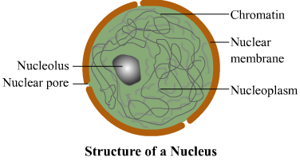

**STRUCTURE – NUCLEAR ENVELOPE**  1. The nuclear membrane forms an envelope like structure called nuclear envelope. 2. The nuclear envelope separates the nucleoplasm from the cytoplasm. 3. The nuclear envelope is composed of two unit membranes :- (i). Outer membrane (ii). Inner membrane. 4. These membrane are 75 – 90 A* thick and lipo-proteinous in nature. 5. Both the nuclear membrane remains separated by a space of 100 – 150 A*. This space is called perinuclear space or cistern. 6. The outer membrane generally remains tough because the ribosomes are attached with it. 7. Sometimes, the nuclear membrane remains continuous with the membrane of endoplasmic recticulum, golgi complex, mitochondria and other cell-organelles. 8. The inner membrane is smooth because it contains no ribosomes. Sometimes it also remains associated with the chromatin. 9. Further the nuclear membrane is followed by supporting of a 300 A* in thickness called fibrous lamina.

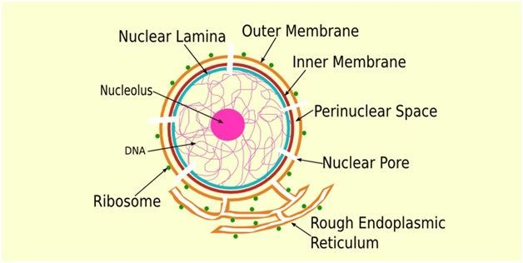

**NUCLEAR PORE COMPLEX**  1. The nuclear membrane are not continuous. They are broken at several places by the nuclear openings or pores. 2. The number of pores may be 1000 – 10,000 per nucleus. 3. At the margins of these pores both the nuclear membrane are continuous. Each pore is fitted with a complex protein structure. So called nuclear pore complex. 4. The pore complex projects into both cytoplasm and nucleoplasm.

**NUMBER OF NUCLEAR PORE**  1. The number of the pores differs in a particular nucleus depending on the species and the types of cells in a species. 2. Generally the number of pores varies from 40 – 145 per square micrometer in nuclei of various plants. 3. The distance between the pores from center to center is about 1500 A*.

**STRUCTURE OF NUCLEAR PORE**  1. The nuclear pores are packed in hexagonal arranged. 2. The nuclear pores are enclosed by a circular structure called annuli. 3. The pores and annuli together are commonly called pore complex. 4. Generally the nuclear pore are octagonal in shape. 5. The pores have about 600 A* diameter. 6. The octagonal structure of the nuclear pore is due to the presence of 8 granules of 150 A* in diameter. 7. The diameter of the annulus is about 1200 A*.

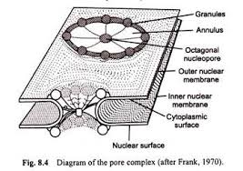

**FUNCTIONS OF NUCLEAR MEMBRANE AND NUCLEAR PORES** The nuclear membrane performs various important functions for the nucleus. Such as :- 1. It keeps the nuclear contents separate from the cytoplasm. 2. It maintains the shape of the nucleus. 3. It regulates the flow of materials into and out of the nucleus. 4. Its pores allows the exit of ribosomal sub-units and tRNA,s and mRNA,s. 5. It maintains the stability of genetic material, protecting it from respiratory breakdown that occurs in the cytoplasm.

**NUCLEAR LAMINA** 1. The nuclear lamina is a structure near the inner nuclear membrane and the peripheral chromatin. 2. It is closely associated with the inner membrane of nucleus. 3. It is a network of protein fibres and gives support to the inner membrane. 4. It connects chromatin to the inner membrane and keeps most of the chromosome in the periphery of the nucleus.

**COMPOSITION OF NUCLEAR LAMINA** 1. It is composed of lamina and lamin-associated proteins. 2. The increasing number of proteins that interact with the lamins and the interactions between these proteins and chromatin associated makes the nuclear lamina highly complex structure.

**FUNCTION OF NUCLEAR LAMINA :-** It is involved in most nuclear activities including DNA replication, RNA transcription, nuclear and chromatin organization, cell cycle regulation etc.

**MOLECULAR ORGANIZATION OF CHROMATIN**  1. The chromatin are embedded in the nuclear sap (nucleoplasm). 2. These are the network of twisted filaments or threads , which are known as chromonemata and their network as nuclear recticulum or chromatin net. 3. These are known as the interphase form of chromosome, which contract and forms distinct chromosomes during cell division. **TYPES OF CHROMATIN** The chromatin can be differentiated into two types :- I. Euchromatin II. Heterochromatin

**I. EUCHROMATIN** 1.The chromatin which stains lightly with the basic dyes is called euchromatin.  2. The chromatin material condenses during nuclear division and spreads in the form of fine threads in telophase stage. 3. It remain as a nuclear recticulum or chromatin net in the interphase stages represent the euchromatin. 4. It is rich in DNA and stains light with basic dyes. 5. It is genetically active material.

**II. HETEROCHROMATIN** 1. At certain regions or the some parts of chromosome are condensed in all the stages of cell division and appear as darkly stained regions. These regions are known as heterochromatin. 2. The heterochromatin differs from euchromatin even in chemical composition and behavior. 3. It is said to be genetically inert and unable to synthesize RNA. 4. But it plays the vital roles like controlling metabolic activity, biosynthesis of nucleic acid and initial attraction of homologous chromosomes at zygotene stage.

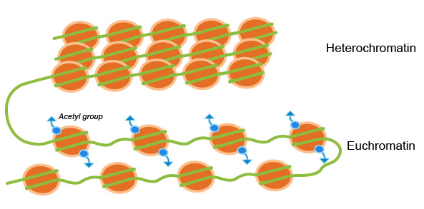

**NUCLEOLUS** 1. It is a large, eccentric situated, spherical, acidophilic and dense granular structure in nucleus. 2. It was discovered by Fontana and was described by Wagner.

**STRUCTURE**  1. Nucleolus is a dense, rounded, dark-staining, granular organelle without a limiting membrane. 2. It consist largely of RNA’s and protein. 3. It also contains DNA which produces precursor RNA’s for the formation of protein. 4. It also contains certain enzymes, such as acid phosphotase, nucleoside phosphorylase, RNA methylase etc. 5. Each cell has a fixed number of nucleoli usually 1 – 4 or numerous. 6. The nucleoli are formed by specific sites called the nucleolar organizers which are present on certain chromosomes. 7. The nucleolus is composed of the following four zones :-

**I. Granular zone** :- i. It occurs at the periphery of the nucleolus and composed of dense, spherical granules of about 150-200 A* in diameter. ii. These represents the ribosome units made up of rRNA and ribosomal proteins. **II. Fibrillar zone** :- i. It is also known as nucleolema. ii. It is composed of many fibrils of 50 – 80 A* long. iii. These fibrils are composed of ribonucleic protein. **III. Matrix or Amorphous zone** :- i. This zone is homogenous, proteinaceous substance of the nucleolus. **IV. Nucleolar chromatin** :- i. It is composed of chromatin fibres of 1000 A* thickness situated around the nucleolus. ii. They contain DNA, which synthesis the rRNA.

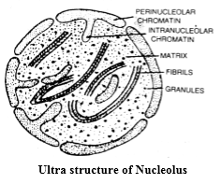

**FUNCTION OF NUCLEOLUS** 1. It synthesis and stores RNA. 2. It stores all the proteins of ribosomes from the cytoplasm. 3. It forms the ribosomal sub-units. These sub-units later leaves the nucleus through the nuclear pore. 4. It also plays a role in cell division.

JANARDAN PRASAD SINGH DEPARTMENT OF BOTANY VISTHAPIT MAHAVIDYALAYA, BALIDIH