**PEA** Vernacular name :- Matar Botanical name :- Pisum sativum **CLASSIFICATION** Class :- Equisetopsida Order :- Fabales Family :- Leguminoaceae/Fabaceae Genus :- Pisum species :- sativum

1. It is one of the oldest edible plants cultivated. 2. They belonged to the variety now called Field Pea (P. arvense) and Garden Pea (P. sativum ) 3. The Field Pea flowers are coloured and the seeds are green or yellow. 4. The Garden Pea are larger and sweeter than the Field Pea. They have white flowers and the seeds may be round, smooth, wrinkled, white or yellow colour. 5. Mendle carried experiment on Garden Pea. 6. Peas are one of the first crops we plant in the early spring. 7. It is an [annual plant](https://en.wikipedia.org/wiki/Annual_plant), with a [life cycle](https://en.wikipedia.org/wiki/Biological_life_cycle) of one year. 8. Pea (Pisum sativum), also called Garden pea. 9. A pea, although treated as a [vegetable](https://simple.wikipedia.org/wiki/Vegetable) in cooking.

**DISTRIBUTION/OCCURRENCE** 1. It is grown worldwide for its edible seeds. 2. It is probably native to South-Eastern Europe and Western Africa. 3. It is a cool-season crop grown in many parts of the world. 4. In world the main Pea growing countries are China, USA, India, Canada, Northern Europe etc. 5. The Pea producing states of India are Uttar Pradesh, Bihar, Haryana, Punjab, Himachal Pradesh, Orissa, Karnataka etc. 6. In India, Peas are grown as winter vegetable in plains and as summer vegetable in the hills.

**NUTRITION** 1. Peas are starchy. 2. Fresh Peas are rich in proteins, carbohydrates, lipids and minerals. 3. They have [fiber](https://en.wikipedia.org/wiki/Dietary_fiber), [vitamin A](https://en.wikipedia.org/wiki/Vitamin_A), [vitamin B6](https://en.wikipedia.org/wiki/Vitamin_B6), [vitamin C](https://en.wikipedia.org/wiki/Vitamin_C), [vitamin K](https://en.wikipedia.org/wiki/Vitamin_K), [phosphorus](https://en.wikipedia.org/wiki/Phosphorus), [magnesium](https://en.wikipedia.org/wiki/Magnesium), [copper](https://en.wikipedia.org/wiki/Copper), [iron](https://en.wikipedia.org/wiki/Iron), [zinc](https://en.wikipedia.org/wiki/Zinc) and [lutein](https://en.wikipedia.org/wiki/Lutein). 4. The seeds are a good source of [protein](https://www.britannica.com/science/protein) and [dietary fibre](https://www.britannica.com/science/dietary-fiber).

**BOTANICAL DESCRIPTION/STRUCTURE** 1. The plant is herbaceous. 2. The Pea plants are semi-erect, climbing or trailing and annual. 3. A Pea is a most commonly green, occasionally golden yellow.

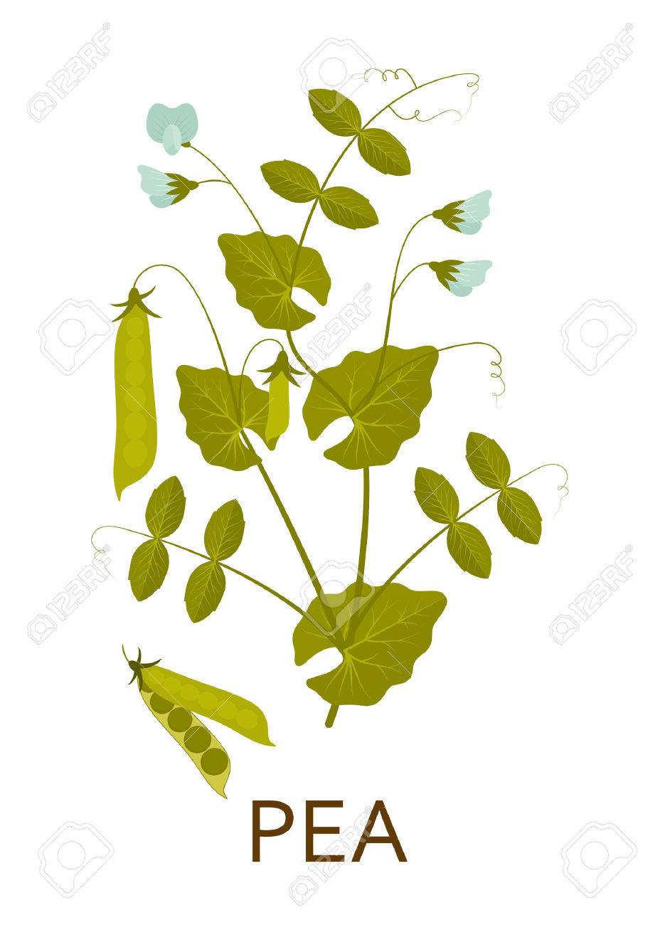

**Root** :- It has a tap root system. he central root is with numerous lateral branches which spread out in all directions. **Stem** :- 1. Stems are slender, usually single, and upright in growth. 2. The stem is cylindrical with hollow internodes. 3. The stem is trailing or climbing that reach up to 1.8 metres (6 feet) in length. 4. The stems has terminal [tendrils](https://www.britannica.com/science/tendril) that [facilitate](https://www.merriam-webster.com/dictionary/facilitate) climbing. **Leaves** :- 1. The leaves are hardy (tolerate bad weather). 2. It has pinnately [compound](https://www.merriam-webster.com/dictionary/compound) [leaves](https://www.britannica.com/science/leaf-plant-anatomy) with 2 – 8 leaflets in pair. 3. The leaves are of green colour, sometimes mottled (unique shapes of different colours). 4. It is ending in a simple tendril and two large, leaf like  stipules  on the base. 5. The lower leaflets are larger than the upper leaflets. 6. The margins of leaflets and stipules may be entire or serrated. **Inflorescence/Flower** :- 1. The inflorescence is raceme arising from the axil of a leaf. 2. The flowers are reddish purple, pink or white, growing 2 – 3 per stalk, are butterfly-shaped. 3. The flowers are single or in groups of 3 – 4. 4. The flowers may appear in different nodes of the stem, depending on the variety. 5. Flowers are with diadelphous staminal tube. 6. Each flower has 10 stamens in two bundles. 7. Nine is in one bundle and one is free forming a separate bundle. 8. The ovary is above the sepals, petals and stamen i.e, Epigynous. **Fruit (pod)** :- 1. It is a legume or pod of green colour (pale or dark, according to the variety). 2. It is oblong of variable shape and size. 3. The fruit is simple, dry and dehiscent. 4. It is pendulous, more or less compressed, and tapered to the ends. 5. The [fruit](https://www.britannica.com/science/fruit-plant-reproductive-body) is 8 – 10 cm. long. 6. They contain 7 – 12 number of seeds. 7. When ripe the fruit splits half. **Seed** :- 1. The seeds are green, yellow, white, or variegated (roan). 2. The seeds are globulose (round) or wrinkled.

**CULTIVATION/PLANTING** 1. This Pea is so easy to grow. 2. It is grown worldwide for its edible seeds. 3. It is generally sown in India as Rabi crop. 4. It is sown from the beginning of October to mid of November in plains and from middle of March to end of May in the hills. 5. For improved germination, Peas are soaked overnight in water before  planting. 6. The Pea is generally sown by broadcasting (scattering seed), but may also be sown by dibbing or behind the plough. 7. Seeds are sown 1” deep and about 2” apart. 8. Plant in rows spaced 12 – 24 inches  apart.  9. The seeds may be sown as soon as the soil temperature reaches 10 °C. 10. The plants growing best at temperatures of 13 – 18 °C. 11. The wood ashes is added to the soil before planting. 12. Many plant reach maturity about 60 days after planting. 13. In the home garden, Peas should be planted in fertile well-drained [soil](https://www.britannica.com/science/soil). 14. The irrigation is very necessary at flowering and grain development stage. 15. If the plants will dry no pods will be  produced.

**HARVESTING** 1. Most varieties of Peas are ready to harvest 60 – 70 days after  planting. 2. If sown in October, the crop is usually ready for harvesting in the month of March or April. 3. The Peas are harvested, when the pods are well filled and the colour of pod changes from dark to light green.

**ECOLOGICAL FACTOR Climate** :- 1. It is a cool-season crop. 2. The seeds may be planted when soil temperature reaches 10 °C. 3. The plants grows best at temperatures of 13 – 18 °C . 4. They do not thrive in the summer heat of warmer temperate. 5. Peas are best grown in temperatures below 21°C. 6. Once temperatures get above 27°C, Peas stop producing pods. **Soil** :- 1. Soil must be well drained. 2. The heavy, [loamy](https://www.almanac.com/plants/soil/loamy) and clay soil is best for Pea. 3. The pH of soil should be [slightly acidic to neutral](https://www.almanac.com/plants/ph/slightly-acidic-neutral).

**SOME VARIETIES OF PEA** 1. There are many varieties of Peas. 2. Some of the most common varieties are :- Asauji, Alaska, Arkel, Matar Ageta – 6, Bonneville, Azad P – 5 (KS – 225) etc.

**USES**  1. The immature Peas are used as a vegetable. 2. Fresh Peas are often eaten boiled and flavoured as a side dish vegetable. 3. Peas are also eaten raw. 4. Dried Peas are often made into a [soup](https://en.wikipedia.org/wiki/Soup). 5. Peas are roasted and salted, and eaten as [snacks](https://en.wikipedia.org/wiki/Snack). 6. Peas  will fix nitrogen in the soil. 7. The pods and seeds are consumed by livestocks. 8. The plants are used for forage, silage and green manure.

JANARDAN PRASAD SINGH VISTHAPIT MAHAVIDYALAYA, BALIDIH DEPARTMENT OF BOTANY